WOMEN'S EDITION

Vol. 3 - No. 6
Whole No. 30
Lake Geneva, Wisconsin, September, 1895

In 1895 The Geneva Herald did something quite unusual for that time period. The editor agreed to let several women put together their own issue of the newspaper, the primary purpose being to generate interest in improving the appearance of the city and in building a new library. The editor did the physical assembly, but the women chose the topics, wrote the articles and selected the graphics. So, we are still in 1895, as observed by the fairer sex. Everything in this number of the LGOT is from that Women's Edition (except for one thing). Enjoy. D.T.

FOR IMPROVEMENT.

Lake Geneva Association For That Purpose

How Can This Be Accomplished.
No City Has Better Advantages Than
Lake Geneva.

What good can an Improvement and Library Association do Geneva? This is a natural question and frequently asked. We are starting out with one truth fully expressed upon our minds. No law can be rightfully enforced, or movement for the public good, meet with profitable results, unless the law or movement represents the wish and will of the people and has their hearty support and approval. Recognizing this truth, we present the claims of the Association, believing that it will meet with the hearty approval of this community and win he moral support of all the people of this city. With this accomplished, the Association will be established upon a firm and secure foundation.

First let it be distinctly stated that this Association represents no particular religious sect, no political party, no personal interests. Its purpose, first, last and always, is for the public good. The beautifying of the town and its surroundings, the improvement of its sanitary condition, the maintenance of a public library and the welfare of the entire community.

Now how can all this be accomplished? With your moral support, your material help and your hearty approval. We would, through this Association, arouse the civic pride and patriotism of the entire community. We should all feel the necessity of making Geneva the loveliest, most beautiful and most desirable of all the notable summer resorts of Wisconsin. The first good an Improvement Association will do is to arouse a spirit of pride among our people in the general appearance of our town.

DON'T BE SO CRUEL.

THANKFUL FOR LAWS PREVENTING CRUELTY TO ANIMALS.

If Everybody in the World Was Kind to Everything in the World, There Would Be Less Pain.

In the beginning man was given dominion over all the animal world - every creature as for his use, but not for his abuse. Someone has said that "Cruelty is Satan's own hand mark." No laws existed in this country for the prevention of cruelty to animals till the year 1865. It could not be expected that a nation which held its dark brother in bondage and inflicted untold torture upon him, could have any sympathy for the brute creatures, except in individual cases. After slavery was abolished Henry Bergh, the pioneer of the humane movement, by much hard work, braving great opposition and derision, he aroused the people to legislate in favor of his cause.
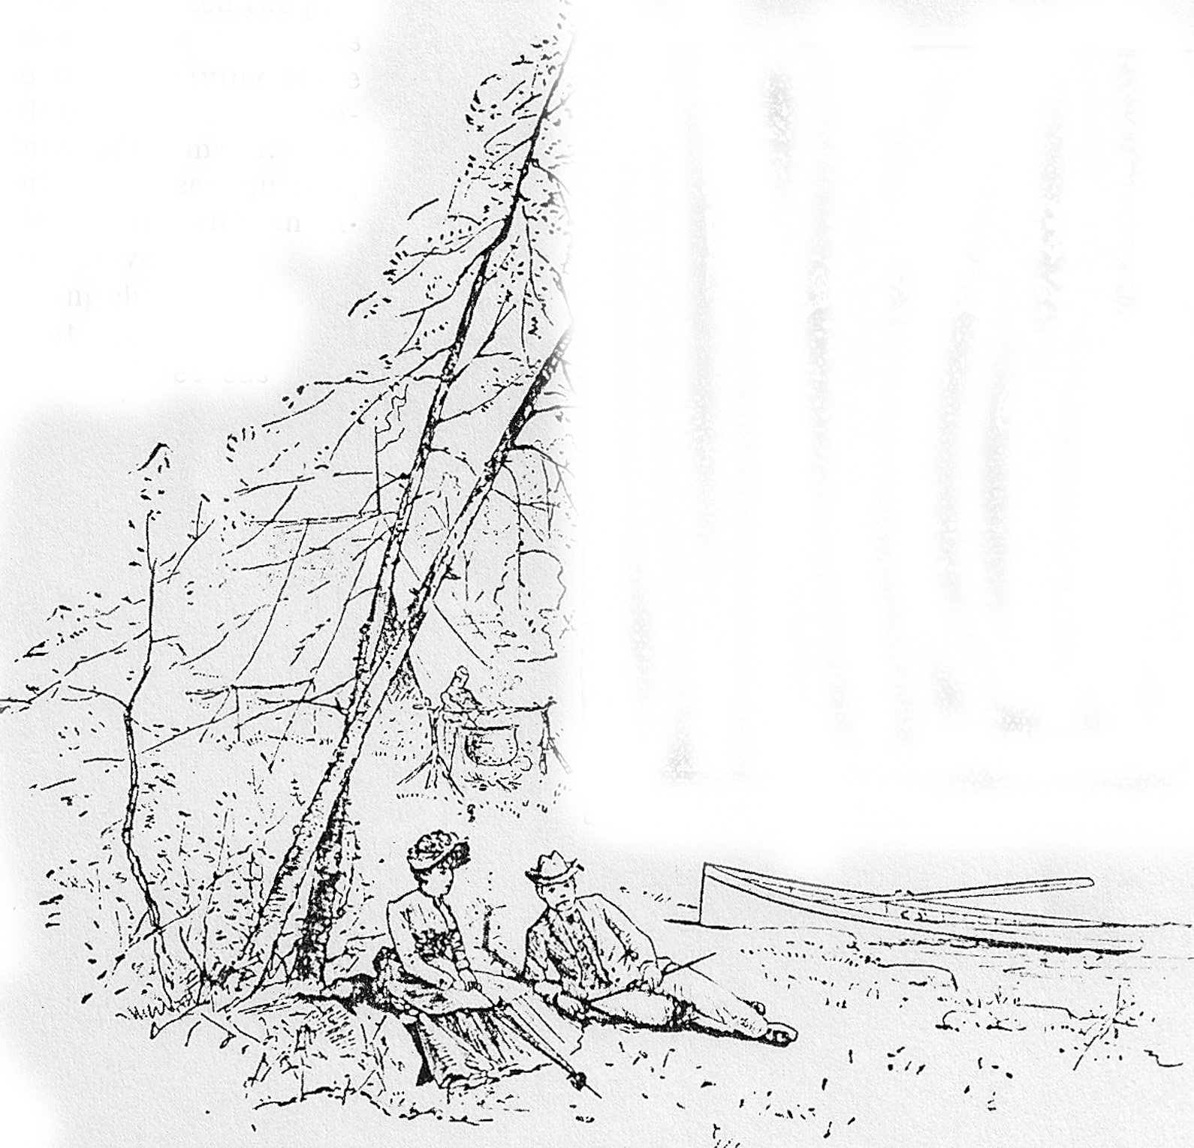

Nature Has Stamped Her

Imprint.

The loving and jealous Goddess

of Nature has stamped her imprint

divine in this lake in the gray

old rock of the ages; has

fringed it with an autum-

nal beauty, rivaling

even the delicate

drapery of

the angels;

has

filled its

geological chalice

with water as sweet as

the water in the goblet of Gough; has made its banks as clean and wholesome as good speech; has made the welcome southwest winds to fan forever its rippling surface and preserve it from all taint and miasma; has jeweled its majestic outlines with rock and pebble of every form and hue, more interesting, more beautiful and more abiding for human happiness than the shining silver or burnished gold, and has tuned its winds to the notes of celestial music.

OLD GLORY'S BIRTH.

The Credit Claimed by Philadelphia.

The birthplace of our flag stands at 239 Arch Street, Philadelphia. It is here that the "sweet and deft needle-woman", Betsy Ross stitched together the stripes and stars of a separate and independent nation. Mrs. Ross had earned the title of being the finest needle worker in America.

Washington was a frequent visitor at her house both before and after receiving command of the army. Mrs. Ross embroidered his ruffles and did many things for him. It was his knowledge of her wonderful a skill with her needle that led Washington to lead Washington, when he was on the committee to for the design of the national flag, to consult Mrs. Ross about it.

He called at her house one June morning and engaged her to make the flag from a rough drawing, which he redrew at her suggestion. It is related that a discussion arose between Mrs. Ross and Gen. Washington in regard to the number of points for the stars. Washington said the stars should be six pointed ones, while Mrs. Ross declared that they should have but five. She decided the matter by cutting a five pointed star from a piece of paper and showing it to the General.

[The who and the how of the first flag was never recorded. This story was first told by Betsy's grandson a full century after the flag was made. Recent research by the Smithsonian staff casts doubt on the veracity of this traditional tale.]

PROSPECTIVE VIEW.

WHAT MIGHT BENEFIT THE LAKE.

Fine Shade Trees and Paved Streets.

The Two Essential Factors in Beautifying Our City.

Blah,

blah,

blah.

HOME SWEET HOME.

ITS CONDITION AN INDICATION OF CIVILIZATION.
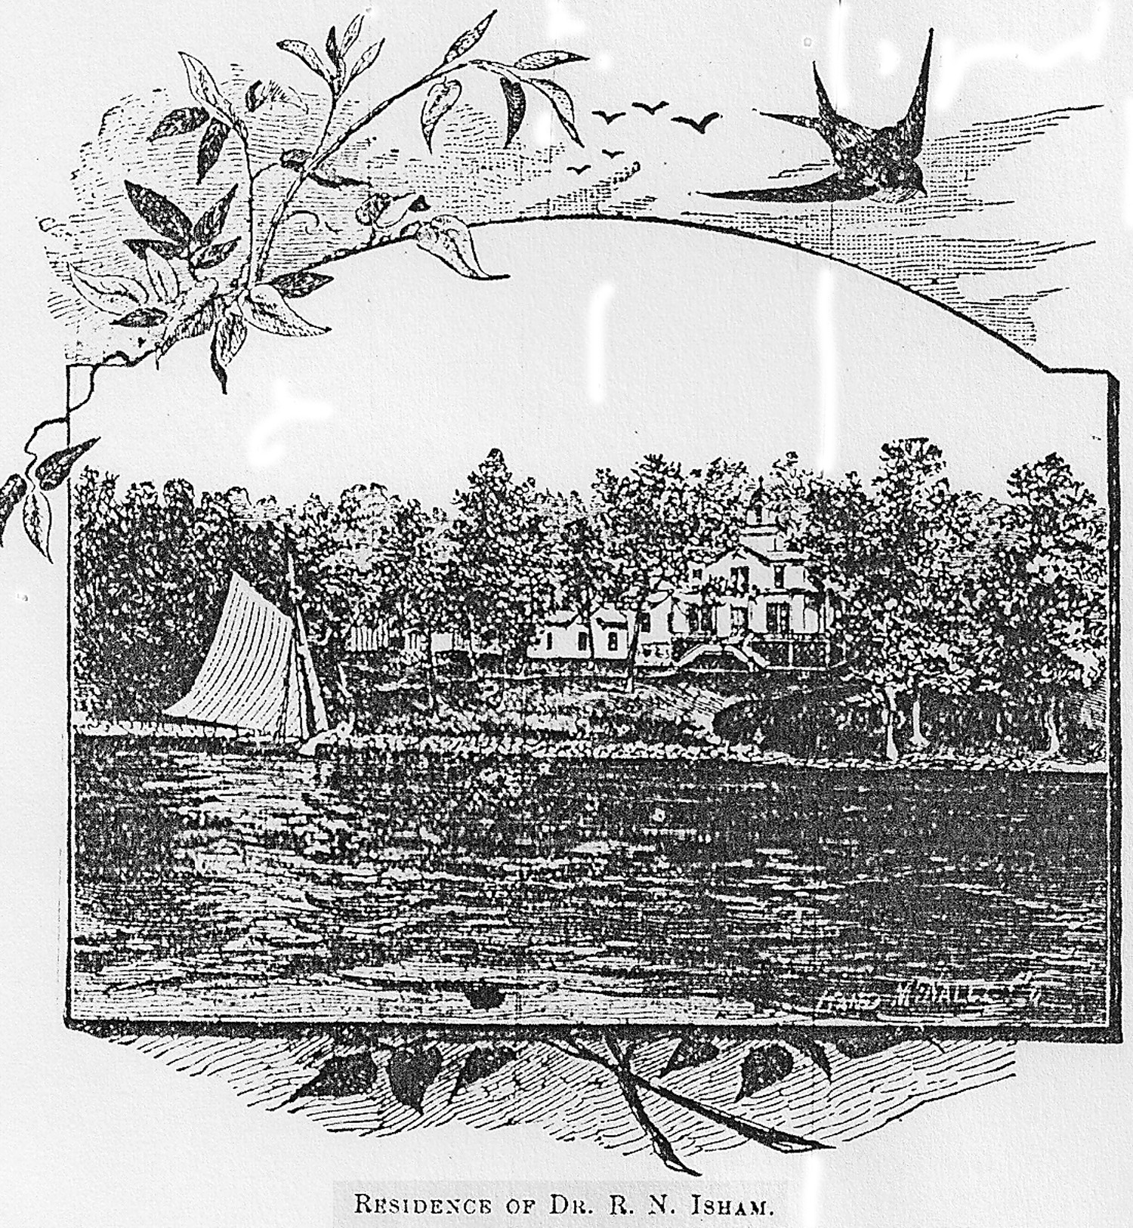

Home and Church Go Together.

The Reading of Good Books Its Best Auxiliary.

It Is Impossible to Overestimate the Results of Early Training and Associations of the Home.

"Home--'tis a blessed name! And they who rove,

Careless or scornful of its pleasant bonds,

Nor gather round them, those linked soul to soul,

By Nature's fondest ties,

Only dream they're happy."

In civilized life the pleasures of "home sweet home" are ranked with our most refined equipments. They have been delineated in the richest elegance of prose and have been consecrated in the sweetest strains of poetry. The condition of the home is an indication of the advancement and quality of any civilization. How much pride we feel in showing our guests from a distance the finest residences of our city. And yet the home sustained by moderate means, by skillful and busy hands, guided by good taste, may rival the home of wealth and luxury.

Home is a little commonwealth in which we first learn and practice our relation to others, and the place where all the faculties of heart and soul that enter into the structure of character are nurtured. That home cannot be a lovely one where the spirit of selfishness reigns. If a child has a propensity to shirk all disagreeable duties upon others, it is not well to shield that weakness by thinking that mayhap he has inherited it from some ancestor. Children should early be taught that each has some responsibility of the happiness f the family.

Delightful Recreation.

The cultivation of flowers is a delightful recreation for children. Let them have their little flower gardens for their very own. Encourage them also to be generous with their treasures. They will soon learn how their beauteous gifts will gladden the heart of the weary invalid.

A great auxiliary to home training is the introduction of the best books and periodicals, and a taste for good reading should be early cultivated.

THE OBSERVATORY.

Largest Telescope in the World.

Through the courtesy of the manager of the Women's Edition of the Herald, I have been requested to contribute some notes on the Yerkes observatory. As the construction of the observatory is now in progress a brief description of the building may not be without interest at the present time. In planning the building the manifold requirements of the investigations to be pursued within it had to be given careful consideration.

Each of the three principle telescopes must have an unobstructed sky. The transit instrument must be mounted so that it can sweep the meridian from north to south. The heliostat must reflect the rays of the sun into a room extending nearly 100 feet from its northern to southern extremity. Rooms for the library, laboratories, offices, etc. must be provided. It is thought that the plan finally adopted after a two year study of other observatories will fulfill these conditions admirably.

The great forty inch telescope will stand on a massive pier of brick and stone in the western tower. As the tube of this telescope, with all o its attachments, is nearly eighty feet long, a dome ninety feet in diameter, with the highest point 108 feet above the ground, is required to cover it. This dome will be carried on large wheels on a circular track bolted to the coping of the tower. Extending from the top of the dome to the base there will be an opening twelve feet wide.

It is expected that the telescope will be in position, and the Observatory ready for occupancy by the first of next October.

George E. Hale

[George Hale was the most famous and respected astronomer of his time. It was a bit of a coup to get Hale himself to write this article for the Herald. The stated size of a telescope is its diameter; wider telescopes gather more of the dim starlight. The Yerkes remains the largest refractor(big lens in front) ever made. Modern reflectors (big mirror in back) are much larger.]

Generosity and Foresight.

Mrs. Mary Sturgis has made a magnificent gift to the citizens of Lake Geneva. She has given her dwelling and lot on block 32 for a public park, conditioned upon the purchase by the city of the adjoining lots, the discontinuance of the streets between it and the lake, and the devotion of the whole to the purpose of a park and of a building for a public library and reading room and other literary purposes. The city gladly embraced this opportunity for procuring what is so much needed to its completeness as a summer resort, and has been busily engaged since the opening of the spring of 1895 in the grading and improving of the grounds. The further carrying out of the beneficent intent of Mrs. Sturges is one of the aims of the Improvement and Library Association and its enthusiastic lady managers, under whose auspices this Woman's edition of the Herald is issued, and the untold advantages which we as a people may derive from the consummation of the work cannot but be evident to all our readers.

Cheapest in the End.

I have used the Royal Baking power for many years and can cheerfully recommend it to all. I consider it the purest, the best and the cheapest of all the baking powders. I have been induced to try other baking powders many times, but I always go back to the old reliable Royal as it always does the work satisfactorily and I believe always the most cheaply in the end.

Mrs. G. H. Burdick

THE HERALD

~~~~~~~~~~~~~~~~~~~~~~~~~~~~~

JOHN E. NETHERCUT.

WOMAN SUFFRAGE.

OPINIONS OF VARIOUS WOMEN ON THE QUESTION.

Do You Personally Desire Suffrage?

Some Wish It; Others Wouldn't Have It as a Gift.

It has been said that suffrage would be extended to women when it is known that a majority desire it. It was thought that a symposium of the subject by the ladies of Lake Geneva would be interesting and the following question has been submitted to as many ladies as could be reached: "Do you personally desire Women's Suffrage?"

Women Equal with Man.

I personally desire Woman's suffrage. 1. I believe that woman was made equal with man and should have the same privileges as far as her strength permits. 2. That sex or color should be no bar to suffrage, but ignorance should. Mrs. Mary Buell.

Proper Antidote for Political Degeneracy.

As new occasions teach new duties, I do not anxiously desire woman suffrage, but I do believe it would be practicable as well as beneficial to the country, and a proper antidote for the political degeneracy of the times. Alice M. Quigley

More for Home, Less for Politics.

I have had time to give the question little thought. I do believe, however, if women gave their attention more to their families and homes and less to outside matters, including politics, there would be perhaps less trouble and unhappiness in the world.

Mrs. G. W. VanSlyck.

Would Settle the Liquor Question.

In my opinion woman should be on an equality with man, as regards voting, when she qualifies herself for it. The weak point in politics at the present time is, that irresponsible, ignorant and unworthy men have the same power as the honest, public-spirited and intelligent man. When woman can find the remedy and use suffrage intelligently and wisely and be ready to work hand in hand with good men, then should it be granted her. Our country will be benefited by it, both morally and socially. Politics will be purer, patriotism in its highest and noblest sense will be taught and practiced and the liquor question soon settled.

[There were nine in favor, four against and three in the middle.]

Married.
Mr. Marc W. Rhode of Columbus, Wisconsin and Miss Megan E. Grimaldi of Plainfield, Illinois .
Mr. Rhode has been graduated from the University of Wisconsin in Madison. He is the son of Dennis and Sanderella Teichow of Lake Geneva, James W. and Janice K. Rhode of Minnesota, and Ms. Ann Ehlenfeldt of Columbus, Wisconsin.
Miss Grimaldi was graduated from Eastern Illinois University, Charleston, Ill. She is the daughter of Edward and Susan Grimaldi, of Grand Rapids, Michigan.
The couple were happily joined in a garden nuptial ceremony among family and friends in Orland Park, Ill. on the evening of August 21, 2010. The bride was beautiful in her white gown and the groom dashing in his black tuxedo. The stifling temperature and humidity caused the bride to swoon momentarily; however, she recovered quickly and the ceremony came to its natural and delightful conclusion. The reception followed immediately in the adjacent hall where good food, lively dancing and merriment carried the evening. Mr. and Mrs. Rhode will reside in Columbus, Wisconsin.
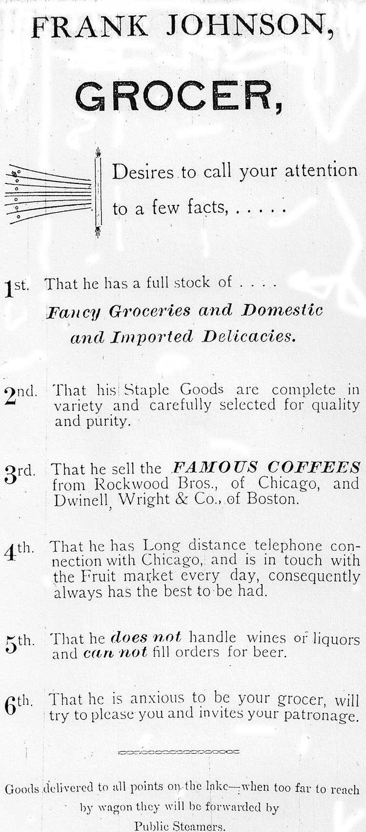

THE COOKING CLASS.

Cost of Meal Discussed When Served.

A Personal Recollection.

A glance into the kitchen of the Women's Union about ten o'clock of a Saturday morning might afford momentary interest to the passer-by. An expectant half dozen girls in checked aprons and white caps await the entrance of the cooking teacher, while a bright fire and humming tea kettle attest the industry of the day's housekeeper. The machinery is set in motion by the arrival of the chief cook and the announcement of a simple menu, such as boiled ham, creamed potatoes, boiled rice. While the market girl runs to choose and fetch the provisions, the waitress sets the table, Leaving three girls to divide the responsibility of the menu. The work advances quickly and quietly and with an interest provided by the glowing cheeks and bright eyes of the workers. One feeds the rice into the boiling water; another prepares the cream sauce for the potatoes; the third trims the ham for the boiler.

Noon finds the dinner prepared and the cooks ready to put their cookery to a most practical test. The red letter day is the one which welcomes as guest the mother of one of the girls. There is an amusing mixture of surprise and appreciation. "Wa'al really, Miss, I'm 'stonished as how Mary creamed thim potatoes. I'd nivir tho't it, nivir! Why I've nivir 'lowed her to do nothin' home, fur fear she'd be a spoil of the mess."

These schools, instead of two classes a week, should be having two classes a day, with not dozens of students, but hundreds of girls. Leila Kennedy

VALUABLE COOKING RECIPES.

Brown Bread.

Two cups of sour milk; one-half cup molasses and a little salt. One teaspoon soda dissolved in water; one third corn meal, two thirds graham flour; thicken about the same as Johnnie cake, Steam two hours then bake to a nice brown.

Fish Puff.

Proportion: one pound fish; one good sized potato; white of an egg, well beaten; cream to moisten; salt and butter to taste. Wrap fish in a napkin and boil half an hour in salt water. Boil potato in separate kettle, mash fine and season. Skin and bone fish and add to potato, beat until very light; stir in lastly the white of an egg, place n a pudding dish, dust with grated cracker or bread crumbs and bake in quick oven.

Mrs. W. J. Cady
The Lake Geneva Old Times is sponsored and financially supported by the Lake Geneva Historic Preservation Commission. Each issue represents one year of authentic old news. It is free to the public. The public may obtain copies at the Geneva Museum, Grandma Vickie’s Café, Dunn Lumber, Piggly Wiggly, Caribou Coffee & Starbucks. Back issues can be purchased for 50 cents each.
Editor, Denny Teichow, 262-248-6313.


