**Vol. 2**

**No. 4**



1882



Geneva, Walworth County, Wisconsin

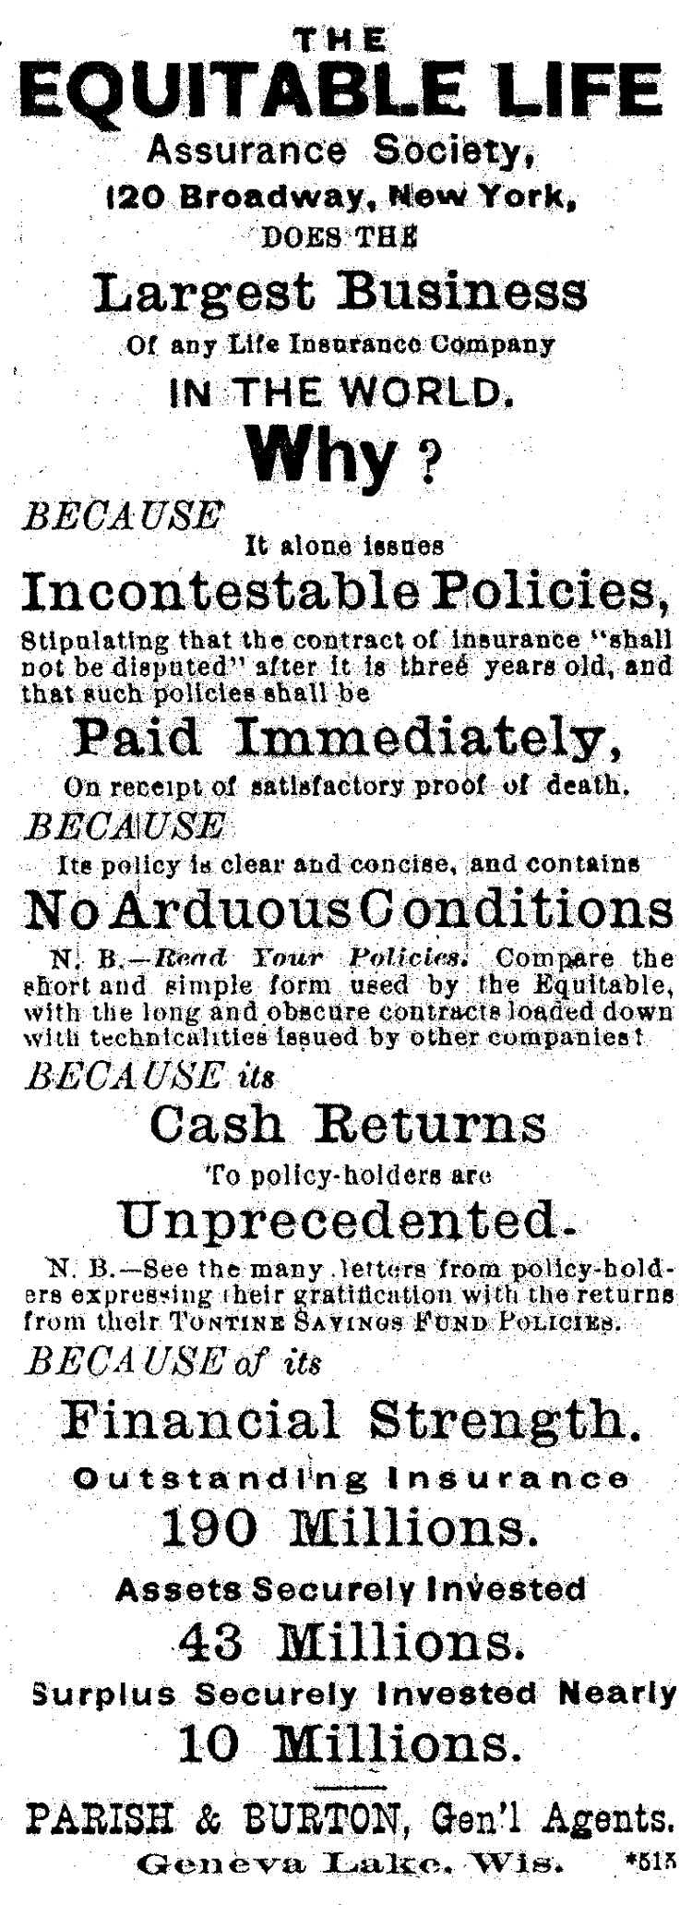

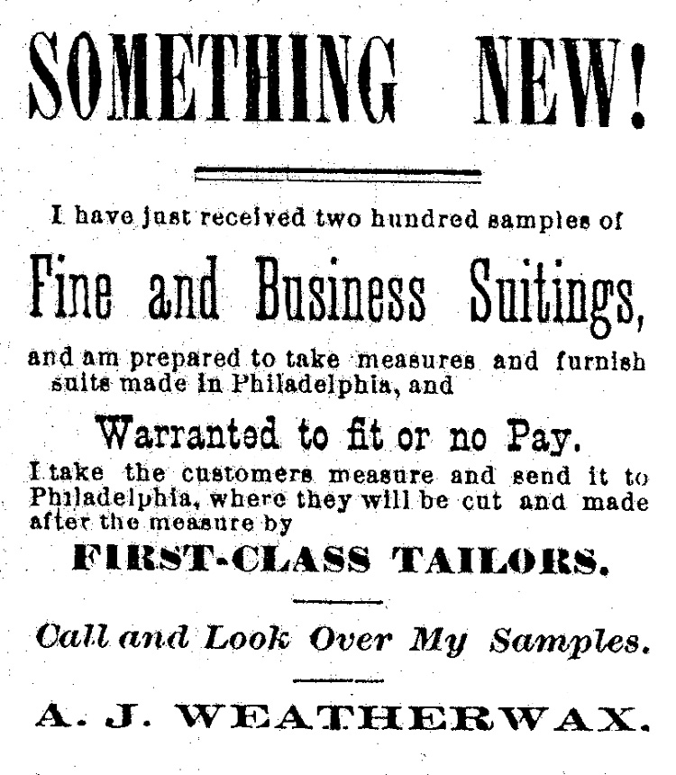

**[** Once again no major stories. Life in this small "western" village just keeps rolling along. People moving in; people moving on. This issue is a little late because the editor's computer was showing signs of alzheimers and had to be replaced.

Happy New Year! DT  **]**

COUNTY ITEMS.

~~~~~~~~~~~~~~~~~~~~~~~~~~~~~~~~~~~~~~~

From our regular correspondents.

# ELKHORN.

--During the past week wood has been more plentiful in this market. Green second growth sells for $4.00 a cord.

--Snow fell to the depth of three inches at the county seat on the 10th, and some light attempts were made at sleighing, but 'twas mighty poor sleighing.

--A runaway horse and cutter which "put up" with a rush at the Central House stables last Saturday, proved to be a livery rig from Geneva, that in some way escaped from the driver.

~~~~~~~~~~~~~~~~

# GENOA JUNCTION.

--T. H. Fellows filled his ice house this week.

--Twelve degrees below zero Tuesday morning.

--The greatest curiosity in this locality of late, has been the coal pit being burned near Twin Lakes, by Wm. Linkey. They have wood enough in the pit for five hundred bushels of charcoal, and will supply the neighboring towns with their coal.

The school is closed in our primary department on account of measles.

~~~~~~~~~~~~~~~~

# LYONS.

--Mr. C. D. Winsor and wife returned home Monday of this week, from their visit to Monticello, Iowa.

--A donation and oyster supper Thursday evening for the benefit of Rev. J. H. Brooks was well attended and the oysters were first class. Net receipts sixty seven dollars.

On Tuesday morning, Mrs. Michael Farley, an old resident of the town started to walk from the house of Mrs. Knight to Mrs. Creighton's house and in some way fell and had to be carried back to the house, at first it was thought that she had fractured one of her hips but the doctor decided there were no bones broken and for a day or so she seemed to be doing well, but the shock was so severe that she did not rally and gradually declined until death ended the scene. The family are scattered in Kentucky and Iowa, but all have been notified by telegram.

# DELAVAN.

--Our glass ball shooters are ready to shoot any glass ball team in this section of the country.

--Our hall in this village is not large enough to hold the crowd that attends the temperance meeting on Sunday afternoons.

--Mr. Frank Goodrich, of this place, has sold his interest in the blacksmith shop of Goodrich & Fisherman to Mr. N. Francisco, who has done the wood work for the shop before, and now the shop will be run by Fisherman as blacksmith and Francisco as wagon maker.

~~~~~~~~~~~~~

# ALLEN'S GROVE.

--Mrs. Reilly is still quite low.

--The concert given by the Scott family was not as well attended as it would have been had the weather been more favorable.

--Mr. Chas. Snell and Mrs. Mary Ingersol, of this place, were united in the bonds of matrimony at Delavan, Sunday last.

~~~~~~~~~~~~~~~~~

# HEBRON.

--Report of the Hebron public school for the month ending Jan. 31, 1882.--Highest in standing: **A** Arithmetic, Sid. Rowe, L. D. Hewes, Hattie Pierce; **B** Arithmetic, Ann Prouty; **C** Arithmetic, Della Cohn; **A** Grammar, Ann Prouty, Sid Rowe; **B** Grammar, Liz Sylvester; **A** Reading, Hattie Pierce; **A** History, D. N. Smith; Physical geography, Sue Slater; Civil government, Sid Rowe; Botany, Sue Slater; Spelling, Ann Prouty; whole number enrolled, 40; average daily attendance, 37; number of visitors during month, 19.

H. C. Faber, principal.

~~~~~~~~~~~~~~

# SPRING PRAIRIE.

--Will Sheffield who has been stopping in Michigan for some time, came home for a visit a few days ago.

--Messrs. McDonald & Blakeman were in Milwaukee the present week for another carload of marble stock.

--Mrs. Harris, mother of Mrs. George Wyhe, was buried in Hickory Grove Cemetery on Tuesday the 11th. inst.

# Young Men's Gospel Column.

====================================

conducted by the young men's committee

====================================

--Topic for Young Men's Meeting Friday evening. "Our help in trouble." Acts 27, 10-14. Bring Bibles.

--Any persons desirous of knowing the particulars of what was done last Saturday evening we would refer them to the docket of our police or any of our city police.

--Of the whiskey sellers in the city of New York, 2,004 have served their time in different state prisons, and 1,769 have been "cooled off" in the station house, leaving only 1,616 out of the 8,034 who have thus far successfully cloaked their deviltry from the police.

**On Thirty Days' Trial.**

We will send Dr. Dye's Celebrated Electro-Voltaic Belts and other Electrical Appliances on trial for thirty days to young men and older persons who are afflicted with Nervous Debility, Lost Vitality, etc., guaranteeing speedy relief and complete restoration of vigor and manhood. Also for Rheumatism, Neuralgia, Paralysis, Liver and Kidney difficulties, Ruptures and many other diseases. Illustrated pamphlet sent free. *Address Voltaic Belt Co., Marshal, Mich.*

**[**Note: Short stories were a common feature in most nineteenth century newspapers. I seldom include them because of space limitations. Here is one example:**]**

# *FLEEING FROM A FORTUNE.*

The sun rose propitiously bright on Grace Sylvester's wedding morn; the air was balmy, the sky blue, and all nature seemed in sympathy with a happy day.

Presently a stir awoke in the household, that soon swelled into a murmur of consternation. The bride was missing. Some one had gone into her chamber to awaken her and found it empty. Immediately a search was instituted which prove fruitless. The bridegroom was sent for but he could offer no explanation.

Grave Sylvester was a proud, impulsive girl, with a warm heart and impetuous temper. She was an only child and somewhat spoiled, as was natural; but nothing that could be imagined could account for this unheard of freak; she had not even fastened a note on the toilet cushion, as a key to the mystery, after the custom of heroines.

For a week previous to this now unlucky day, the Sylvester mansion had continuously opened its hospitable portals to arriving guests. This singular occurrence therefore, could not possibly be preserved as a secret, and the hostess had the added misery of knowing that their daughter's inexplicable flight was the subject of all sorts of surmises.

But a special gleam was soon destined to illume the darkness. Grace had not been unmindful of her dear parents, nor her devoted lover. A letter addressed to the former had been dropped by her at the postoffice. It was brief and evidently written under the pressure of excitement.

Its contents may be rendered thus:

She had left of her own free will and unaccompanied, though she would be met at her journey's end by a worthy guardian, in whose care she would remain, and who, at the expiration of a week, would bring her home again; until then she begged they would wait for her explanation and above all forgive any pain her hasty disappearance had caused.

This epistle, though gratefully received, was not, of course, entirely satisfactory to her parents and lover. Despite her promise to return, they could not remain quiet, but sought her in every conceivable place.

One by one, or in small parties, as they had come, the wedding guests departed. They carried to their own houses a charmingly inexhaustible theme for gossip and wonderment. Every one held a separate solution and theory.

But only one of them possessed any clue to the truth--and she, shy, insidious plotter that she was, had laid a train whose success promised even beyond here hopes. She watched silently, awaiting the fulfillment of her design. She professed the intensest sympathy for all, at the same time contriving to bestow most of it on Frank Howard, her distant cousin.

This young lady, May Prescott by name, had long been hopelessly bin love her with Cousin Frank. She knew that his heart was devoted to another, but never had an opportunity of seeing her rival till the generous and unsuspecting Grace had asked her to be one of her bridesmaids.

May's darling object was then gained. She had unlimited faith in her own power of creating discord, and had secretly resolved to separate the lovers and win Frank for herself, even at the eleventh hour.

Her first interview with Grace convinced her that Grace's impulsive generosity was the strong point of her character. On this she acted.

"How oddly the gifts of fate are distributed!" May said as they were talking together the night before the wedding. "One would think it was enough to get a beautiful wife, without grasping at a great fortune, too, but then Frank always had a keen eye for the main chance." Grace's face flushed a deep, indignant crimson; her bright eyes flashed with sudden anger as she looked at May.

"Pray explain yourself, Miss Prescott. I do not understand you in the least."

"What! You have never heard of the will of Frank's eccentric old Uncle Paul? Perhaps Frank did not mean to deceive you, but just did not want you to know."

"Tell me all there is to tell," May insisted.

May closed the door and poured iinto her victim's ear the story whose result was Grace's flight from her home.

The week passed anxiously for the three people who were awaiting the wayward bride's return. On the morning of the appointed day a carriage stopped at the Sylvester mansion and Grace alighted from it. She walked into the house with an air of mingled triumph and deprecation. Mrs. Sylvester, with attempted sternness, demanded the promised explanation, and this was the story:

"The night before my wedding day I learned from some one that Frank was about to inherit $100,000 upon a strange condition. His uncle had died and left that amount to him, provided that he marry me within a year after the testator's death.

"I had never seen this uncle, but as I had learned from my informant, he had met me by chance in one of the New York hospitals. On my first visit there, I was seized with a desire fancy to vary my round of pleasures by an afternoon among the sick, to whom I carried the ever-welcome gift of fruits. An old gentleman was attracted by this whim of mine and made up his eccentric mind that Frank should marry me lose a large fortune.

"Now, though I am deeply obliged for the honor meant me by the deceased, I positively decline to be bartered away to anyone at a stated price.

Do you not understand, and can you not sympathize with me? Had I remained here no explanation could have altered the case, and I should have inevitably become Frank's bride. under conditions alike painful to my love of truth and respect. I have always declared that I would be loved for myself alone, not for qualities I did not possess, nor the money of a whimsical old gentleman.

She drew a long breath as she finished her recital...

**[**But wait! There's more! See next month's issue of the Old Times to discover the exciting conclusion of "Fleeing From A Fortune."**]**

The Herald.

Lake Geneva, January, 1882.

The Herald contains this week over forty columns of pure reading matter.

Last week C. B. McCanna sold 1,200 pounds of creamery butter at 41 cents per pound.

Wm. Kirk of Bangs Bros., furnaces, has been in town this week repairing the furnace in Geo. Sturges' residence.

Dan E. Sherman has fitted up room 8 in Metropolitan block for a law office, and takes possession.

Somehow a rumor has got around that lawyer French has been attending prayer meetings of late. That may be why he has been so successful in criminal cases.

Railroad Commissioner Turner favors us with a copy of his new railroad map of the state, corrected to January first, and showing the contemplated route of the C.P.&S.R.R.

Harvard, Ills. is making large inducements to draw manufactures to that place, has already raised a large sum as a bonus to manufacturers of the right kind. Geneva has got to do something of the kind pretty soon.

A young couple came from Winsor to this place Tuesday noon and were married at the Catholic church by pastor Rev. Father Zimmer. They returned to Springfield for dinner and left by the afternoon train.

Of the $18,000 taxes paid by this town, nearly $15,000 were paid before the first of January. Before the first of January the treasurer has one percent, for collecting, and after that time five percent.

Invitations are out for the marriage of Mr. Emery A. Buell, of Slade's Corners and Miss Lou W. Miller, of Burlington, on Tuesday.

A McHenry cheese maker pounded himself on the head with a club and reported himself robbed of $2,100 of the patrons' money, and was caught at it.

The ice company has the track laid from the ice houses to the lake, and expects to begin work to-day and continue for three to four weeks. A stationary engine will be used at the upper end of the slide to elevate the ice into the houses.

The small pox patient in Lyons died on Friday last, and there is but one known case in the county, and that too is in Lyons.

Three tramps came to Geneva by freight on Tuesday noon. Marshall Thomas showed them the way to Springfield and they have not been heard from since.

A year ago at this time we were all struggling to dig out of snow-drifts twenty feet deep. Now, the mud is about that depth, but no sign of snow.

There is absolutely no foundation to the report that a new hotel was to be built here. The rumor originated from a mistake made by a telegraph operator in receiving a message for the Herald.



The Fun and Folly Minstrels, an amateur troupe of Geneva, Wis., gave two entertainments at Ayer's hall this week. The hall was well filled and the performances well received. Although there was a freshness apparent which is not seen in older companies, yet in the main, all the parts were well carried. The choruses were up to standard, and some of the character parts were especially fine. The German characters by C.C.Buell and F.P. Davenport were hard to excel and the aged African slave couple by W.J. Cutteridge and J.B. Sherman appeared to advantage. The performance closed with the "Virginia Mummy," in which all the parts were well taken.

*The Harvard Independent.*

The subject for debate at the Lyceum next Monday evening is "Resolved, that the government of the United States is tending toward a monarchy," to be discussed in committee of the whole.

**[**I think we could have had the same debate in recent years.**]**

Invitations are out for a social dancing party at C.C. Deignan's new hall, Genoa Junction, to-night. There will be good music, and Mort. Rogers will do the prompting.

# To the Citizens of Geneva.

Mr. W. H. Stennett, General Passenger Agent of the C.&N.W.R.R., has written to the editor of the Herald saying that if the people of Geneva will furnish him 25,000 copies of the *Cisco* by first of April, he will send men to various southern cities with them and see that they are distributed. Thee is no question but that the *Cisco* has been the means of bringing many visitors to the lake. Nobody doubts it. The railroad must treat all the summer resorts along the road alike. It has therefore arranged for a pamphlet of its own, describing all the places--Sparta, Waukesha, Green Lake, McHenry, etc., etc.--impartially. But it will distribute all the *Ciscoes* that may be sent in. Now the expense of getting this large edition in first class style would be heavy and more than the hotels could stand. But , as it would help increase the value of property here, it seems no more than right that all citizens should join in and get it out. Two years ago we sent 5,000 copies south , the cost being paid by Messrs. Watson, Kaye and ourself. At that time land around the lake was worth $100 per acre, now it is scarce at $300. Not another resort in the whole country has seen the same progress.

**[**Any local historians out there know anything about a publication called the *Cisco*?**]**

# ANNUAL MEETING OF N.W.D.A.

The 16th annual convention of the Northwestern Dairymen's Association will be held in the Opera House at Geneva Lake, Wis., and will be called to order on

Tuesday Evening, Feb 14, 1882

when the following exercises will be had:

Song--Geneva Lake Male Quartet

Address of welcome--John Boyd, Esq., Geneva Lake.

Wednesday Morning.

Advantages of the Cream Gathering System--C.C. Buell, Rock Falls, Ill.

Wednesday Afternoon

The Mistakes of Northwestern Farmers in Preparing Winter Feed for Their Stock--S. Favel, Delavan, Wis.

Thursday Morning.

Considering the claims of J.A. Hubbell & Co. for royalty on cheese hoops, fillers and bandages.

Thursday Evening.

Grand Banquet, musical festival and social at the Opera House

If any person has one honest objection against Christianity, and he desires to have it considered and answered, let him write it out over his signature and hand it to me or send it through the post office. I will keep his name sacred, and do my best to give an intelligent answer from the pulpit. Will give notice of same beforehand through the papers.

J.E. Ambrose, Pastor Baptist Church.

# *DATES WORTH REMEMBERING.*

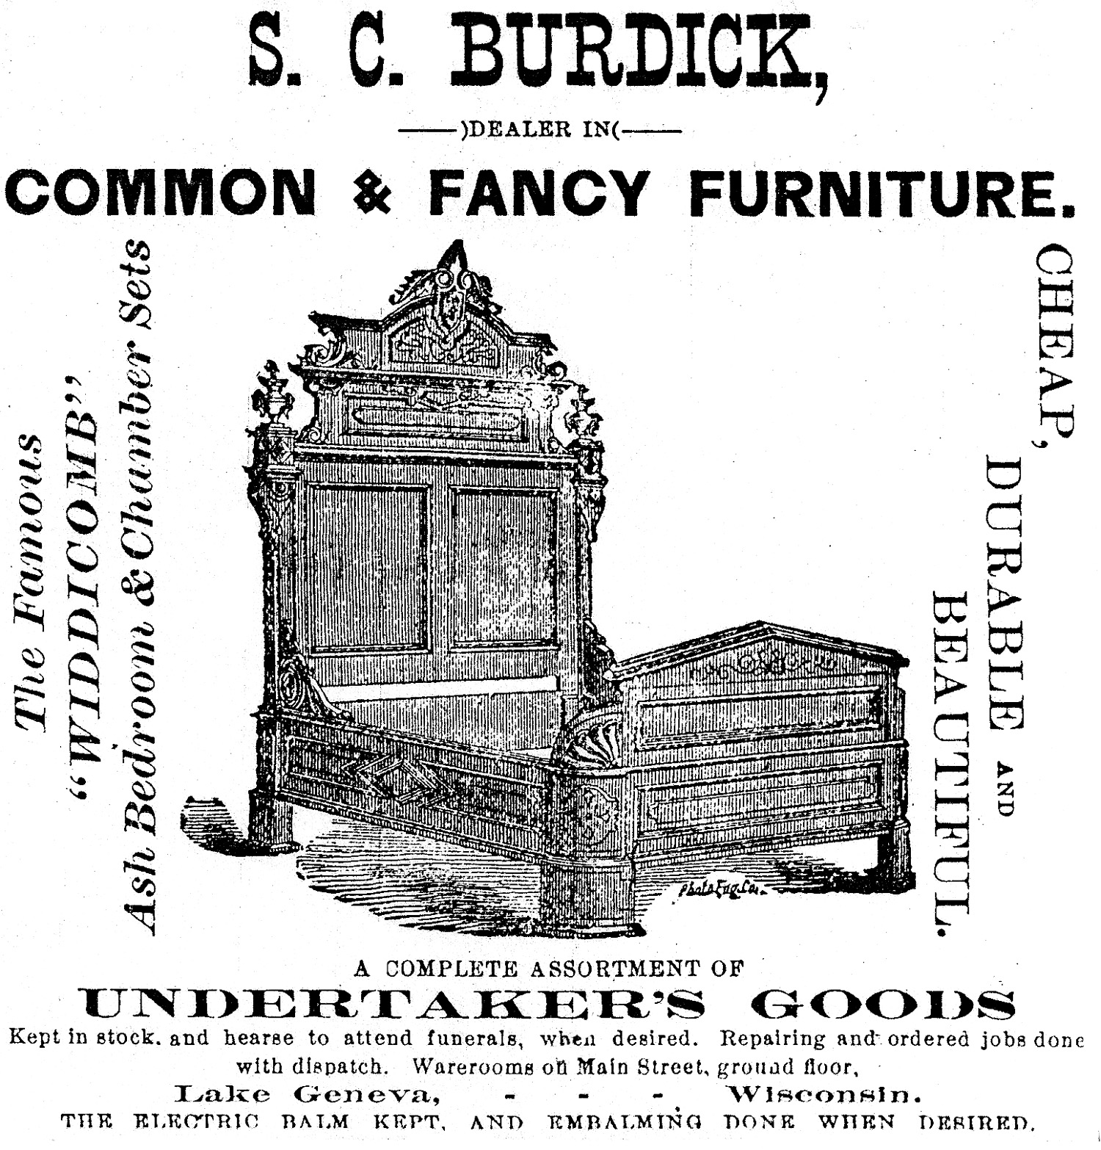

1110 - Glass windows first used for light.

The *Lake Geneva Old Times* is sponsored and financially supported by the Lake Geneva **H**istoric **P**reservation **C**ommission. Each issue represents one year of authentic old news. It is free to the public. The public may obtain copies at the Geneva Museum, Grandma Vickie’s Café, Dunn Lumber, Piggly Wiggly, Caribou Coffee & Starbucks. Back issues can be purchased for 50 cents each.

Editor, Denny Teichow, 262-248-6313.

1236 - Chimneys first put to houses.

1252 - Lead pipes for carrying water.

1297 - Spectacles invented by an Italian.

1334 - Woolen cloth first made in England.

1449 - Art of printing with movable type.

1468 - Watches first made in Germany.

1549 - Circulation of blood discovered by Harvey.

1690 - Jupiter's satellites discovered.

1704 - Tea brought from China to Europe.

1603 - Theater built by Wm. Shakespeare.

1627 - Newspapers first established.

1640 - Pendulum clocks invented.

1640 - Steam engines invented.

1650 - Bread first made with yeast.

1662 - Fire engines invented.

1759 - Cotton first planted in United States.

1785 - Stereotyping invented in Scotland.

**[**What?**]**

1788 - Animal magnetism discovered by Mesmer. **[**Highly controversial, even then, later discredited.**]**

1832 - Telegraph invented by Morse.

1880 - telephone invented by Bell.

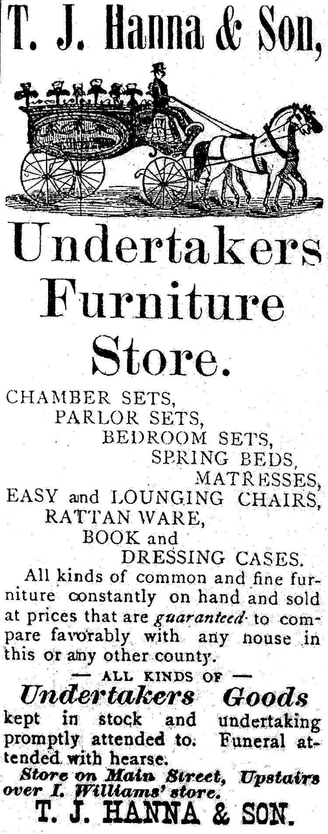

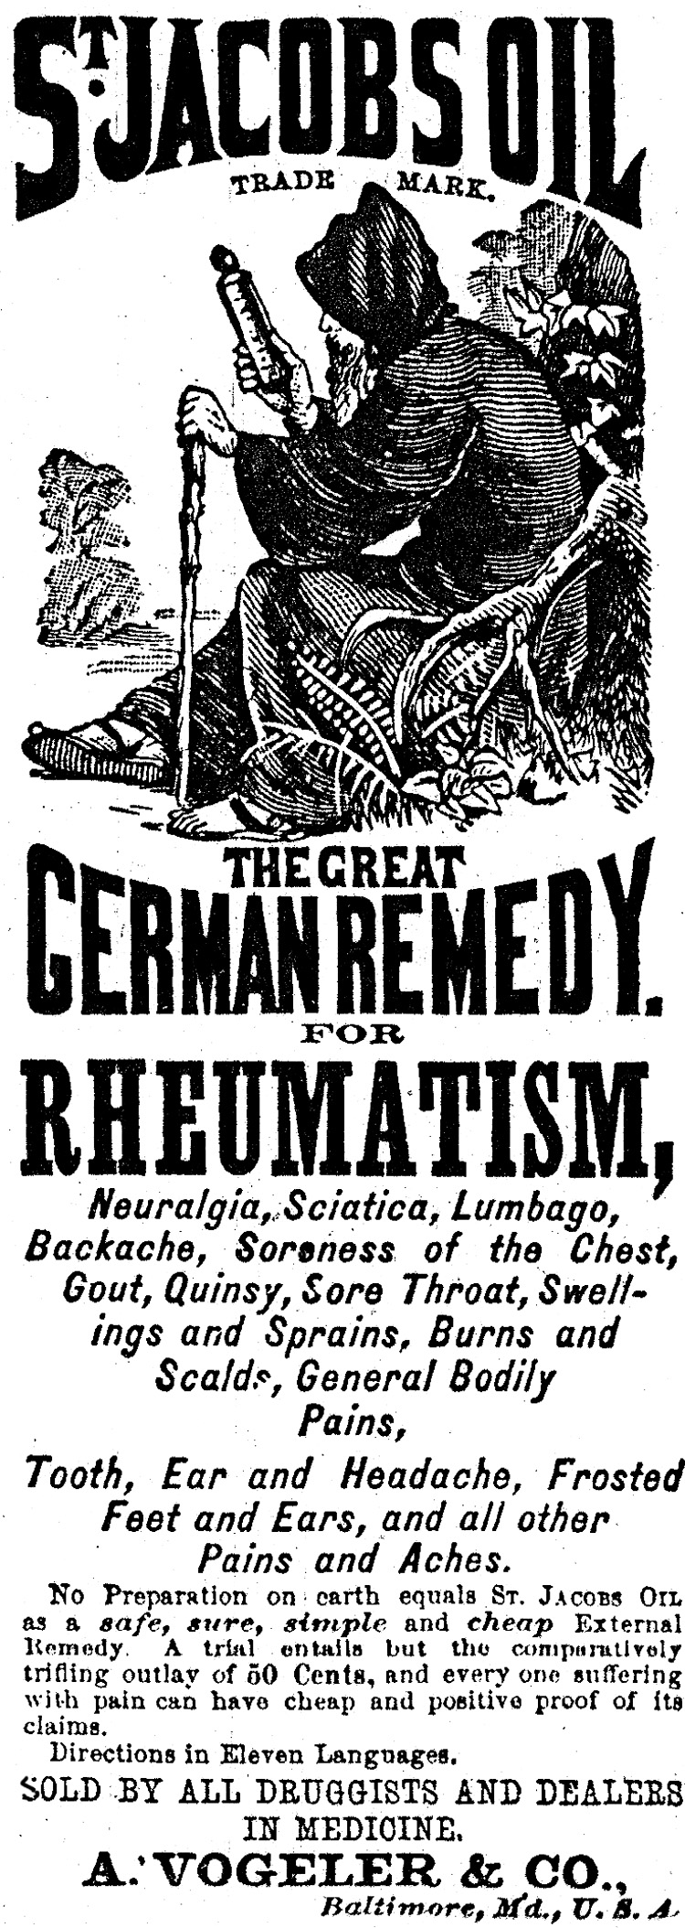

Pickled Pineapples.--Seven pounds fruit, three pounds sugar (brown), one quart vinegar, one-half ounce cloves. Slice the fruit one-half inch thick, sprinkle spice between layers. Scald the vinegar and sugar, and pour over the fruit three days in succession. Musk melons are very good prepared the same way.

