Vol. 1
No. 9
1875

Devoted to Progress and all that Makes Humanity Better.
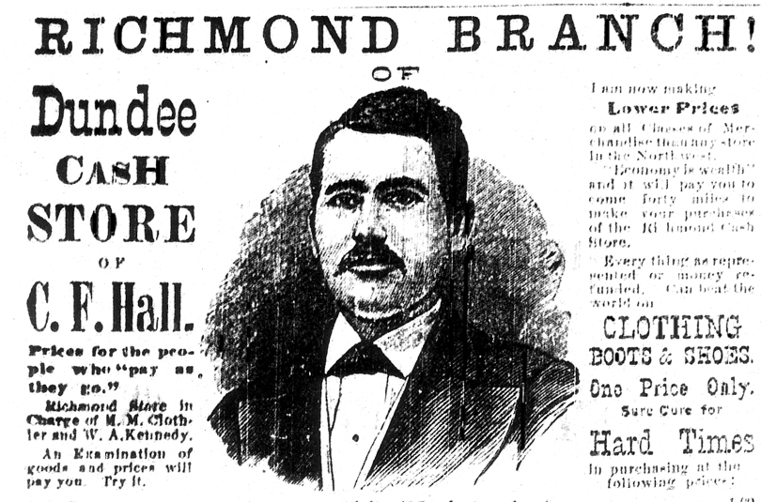

The Herald had abundant advertising. In this issue of the L.G.O.T. we will offer more examples than usual. And beginning in this issue there will be one ad for a current business among the old ads. See if you can spot it.
Henry Ward Beecher was a prominent, liberal clergyman. The 1875 adultery trial in which he was accused of having an affair with Elizabeth Tilton was one of the most famous American trials of the 19th century.



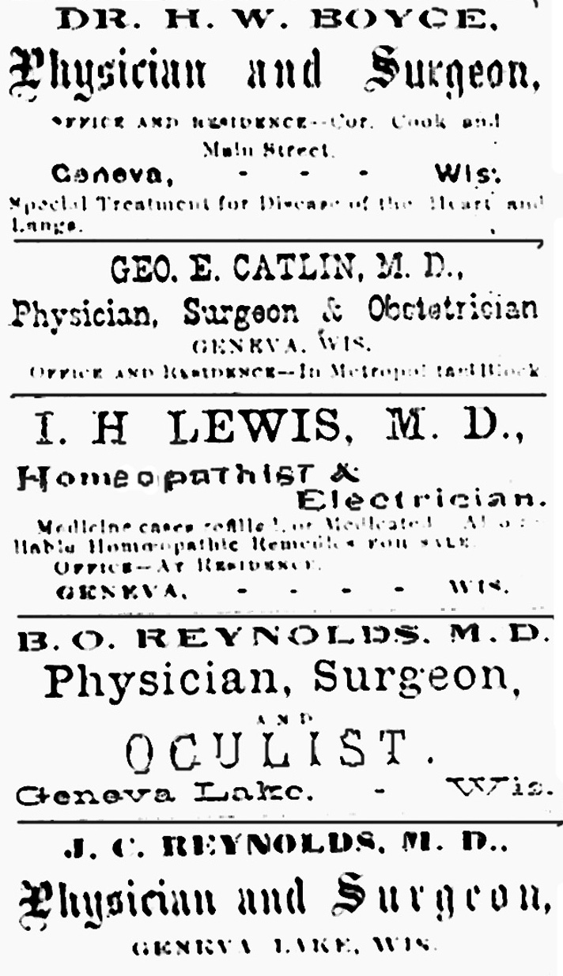

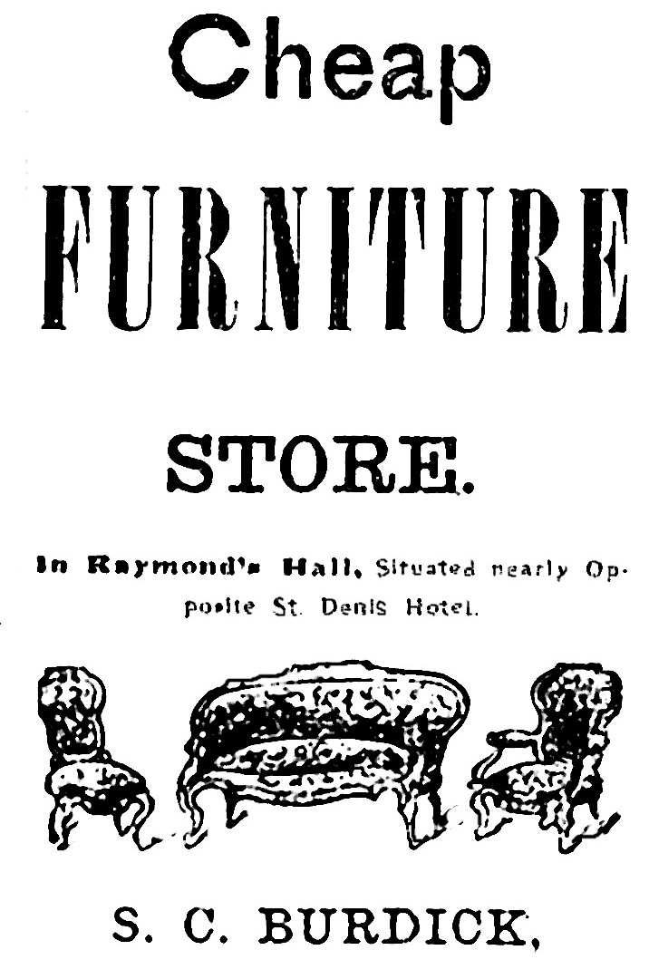

THE GREAT SCANDAL

Effect of Beecher’s Two Day’s Testimony.

MOULTON ANXIOUS, TILTON RUINED. “BROTHER” RICHARDS OSTRACIZED.

Betting on the Verdict, etc.

Henry Ward Beecher’s testimony yesterday and Thursday produced a most profound impression upon his hearers. There is no question upon that point. As one of the news papers hostile to him says, “there was mesmerism in his voice.” Accustomed to swaying audiences and to carry them along with him, his experience in this direction proved most valuable to him on the witness stand, and whatever may be their final conclusion, all who listened to him, except for plaintiff and counsel, for the time being, at least, believed him innocent. The change going on in public sentiment regarding him here in Brooklyn continues to be very rapid. Still all this may be changed when Mr. Beecher’s cross-examination has occurred, and there is no doubt that there will be plenty of the latter.

moulton on the ragged edge.
Mr. Moulton, who had become most popular in Brooklyn and New York since delivering his testimony, now grows very anxious and nervous as public favor changes in favor of Mr. Beecher and the prospects of his acquittal brighten. He is far too shrewd a man not to see that Mr. Beecher’s acquittal means his utter ruin here.
Tilton ruined anyway.
Mr. Tilton has admitted that his wife had left him on two occasions, and on one of those he had taken her infant child to pressure her return. Whatever may be the upshot of the trial, Mr. Tilton is irretrievably destroyed, so far as Brooklyn is concerned. No amount of rebuttal can obliterate the belief that he has been a thoroughly bad man, and that he has repeatedly falsified while on the witness stand, and by endeavoring to give himself a too clean bill of morality, completely overshot the mark.

[Mr. Moulton & Mr. Tilton were acquaintances of Rev. Beecher. In response to their accusations, Beecher accused them of black mailing him. To find the result Google “Hendy W. Beecher.” ]

Geneva Lake Herald.
Issued Every Saturday Morning,
at
G E N E V A,
Walworth County, Wisconsin

Republican, Anti-Monoply and
FAMILY NEWSPAPER
The Herald is the Largest newspaper printed in Walworth County.

Gold in New York yesterday, 116.

The national debt was decreased in May $4,189,000.

The Beecher trial is now in session for its 164th day. Just a little tedious.

A rumor says a movement is on foot to build a R. R. from Harvard to the west end of Geneva Lake, to connect us with that branch of the N. W. R. R.

The Sioux Indians have thus far failed to agree with the President and Sec. of the Interior on a sale of the Black Hills. An offer of $25,000 was made to them, all in cash, for their claims in Nebraska, but they are shy of it and yet hardly know how to go home without it.

Kaye’s Park has its opening for 1875 next Tuesday, June 8. These lovely grounds have been improved the past spring. The Opening calls for a match game of Base ball. Dancing from3 PM to 12 PM, music by the Quadrille band of Geneva, and all free. Both steamers are expected to run touching day and evening.

The daily wagon loads of large trunks from the depot tells us to a certainty that the season is upon us. Already a considerable number of our old visitors are back again.

OBITUARY.
Death of One who has spent more than a half century in ministerial labor.

Elder Noah Barrell who died at his residence in Geneva Lake, Wis., April 16th was born in Hartford, New York in 1794. He stifled his early religious convictions but finally yielded to the gracious spirit and was converted in his 19th year. His conversion and his call to the ministry were inseparably connected. He preached his first sermon in 1820 and preached his 50th anniversary sermon at East Delavan in 1870.
During those 50 years he had been pastor in 15 churches in New York, Ohio and Wisconsin.

WATER WORKS FOR OUR VILLAGE.

The question of fire in Geneva is one often contemplated and always with real grounds for apprehension. Most of our winds are west and often severe. A fire originating anywhere west of the Metropolitan block with a strong southwest wind would destroy most of our village, and leave the business prospects buried for a season in the ashes that marked the trail. Geneva has been for long, long years a very favorable village in the matter of fires, But how soon the fiery fiend may lap us up in one fiery breath is the serious question, which none can answer.
A good fire engine with sufficient hose, is an expensive affair and demands the time and attention of a company of not less than 50 effective men. Its cost and care for the first year not be less than $4,000.
The proposition to be laid before our village is this: Messrs. Shelton and Buckingham Sturges have on the summit of the Sturges hill a mammoth reservoir, holding thousands of barrels of water, and through their native generosity have offered this village the use of water, if we saw fit to properly connect the village with the reservoir with tubing..
The distance a pipe would need to be extended would be about 2,600 feet and can be obtained for about $1.10 per foot if the people will make a beginning on the trench digging. The smaller pipes leading to various streets will aggregate to not more than 650 rods. These smaller pipes can be laid at a much less expense, not only to, but through every house, even to the highest story, where the use of a faucet will make the water a thing of great convenience, comfort and economy. But the highest value to our village would be the safe guard which would be thrown around us in case of fires

Stacks of wallpaper that cannot fail to please, at Curtis’s.

The condition upon which our citizens gave their $400 for the purchase of Silver Cornet instruments was, that should the Band using them break their organization, the instruments should be properly packed and left in the keeping of the Village Board. This agreement should be faithfully kept.

Large quantities are being hauled to the brick yard owned by Mr. Beamsley. He expects, weather permitting, to make 500,000 bricks this coming season to supply his numerous customers.

Two large, heavy young horses wanted by the Manufacturing Co.

ABOUT THE FISH IN GENEVA LAKE.

It is not considered in law that fish have rights, but inasmuch as fish administer to the needs and comforts of men, the State, in respect for its citizens, has legislated in favor of protecting the fish for man’s benefit. The same is true of shade trees. The tree has no rights we are bound to respect, but, we are by law required to respect even shade trees, as an indirect way of ensuring the rights of citizens. The same is true of horses and other animals.
Geneva just now is particularly interested in the law which forbids fishing in the lake. Some say they have the right to fish with a hook at all times, but from the law, it will be seen that no one can catch in any way whatsoever between January 1 and April , and according to the general law for Walworth county, no pickerel, muskellunge, pike, perch, black bass or growlers can be caught in any form until after the 30th day of April.
The money to build the new German Lutheran church has been nearly all subscribed and it is expected that work will begin soon. The society intend to purchase one acre of ground in this part of town

WALWORTH COUNTY.
Spring Examination, 1875

At Delavan, March 30 and 31
At Geneva, April 6 and 7
At Whitewater, April 12c and 13
At Elkhorn, May 7 and 8
Examinations will commence promptly at ten o’clock A. M.
District Clerks receiving this notice will please notify Teachers.
S. P. Ballard
Co. Supt. Schools

BORN.
To Mr. & Mrs. Christian Albright, of this village, on the 19th of March, a son.

MARRIED
EVANS – WHITAM – by Rev. J. S. Hewitt, March 20, Mr. Richard Evans of Beloit and Miss Emma Whitam of Geneva. Waukesha paper please copy.
By Rev. L. Ford at Sharon, March 16, Douglas W. Spencer and Hattie Winters.

The Geneva Lake Annual Champion Cup to be sailed for on the Fourth of July, may be seen at C. E. Buhre’s store. It is beautiful in design and workmanship, and is free to all vessels owned here, without entrance fee. The cup is the property of the winner and not subject to future contests.

WISCONSIN NEWS.

A Columbus, Wis. cow dropped dead of heart disease.
Prof. Parkinson will deliver the oration at Mineral Point.
“Blind Joe” Putnam, of Lamartine, shot and killed himself last week.
The Columbia County fair has been permanently located at Portage.
Montello shows 884 inhabitants, an increase of fifty in the past five years.
A Sauk County cat has adopted a chick to supply the place of a deceased kitten.
The pickle factory at Janesville will be furnished with cucumbers from 393 acres in various parts of the county.
There are nine pairs of twins in Janesville.
A man named Otis, living in Dekora, Columbia county, aged 88 or so, and in good health, had a had a complete set of natural teeth come in about three years ago. He also received his second sight about 25 years ago.
A plowing match will be one of the attractions at the next Waupun fair.
Much damage has been done in Juneau county by the chinch bug.
A man destitute of clothing was found in a woods in Vernon county on Wednesday; several men pursued and captured him, but they could get no information from him in regard to his clothes. This, together with his wild talk, led them to believe he was a maniac, and they clothed him and brought him to Viroqua.
Three lads named Wm. Christy, Tansom Kingsley and Timothy Eaton, are under arrest for robbing J. G. Funk’s store at Wonewac.
On Sunday, Mr. D. A. Davis and his two daughters, after eating dinner, were suddenly taken very sick; they exhibited every indication of having been poisoned and suffered great pain, being thrown into convulsions. Dr. Meacham was summoned and concluded that the poison had come from a can of peaches they had eaten for dinner. The peaches had been preserved for about two years. The latest information received by the reporter was to the effect that unfortunate victims were better and that hopes were entertained for their recovery. – Racine Journal.

SUNBEAMS

No young man is proof against a gumdrop when she holds it between her teeth and invites him to take a bite.
A St. Louis woman received $300 dollars from a dentist who broke her jaw. Her husband furnished the dentist the money.
GENEVA LAKE WIS.
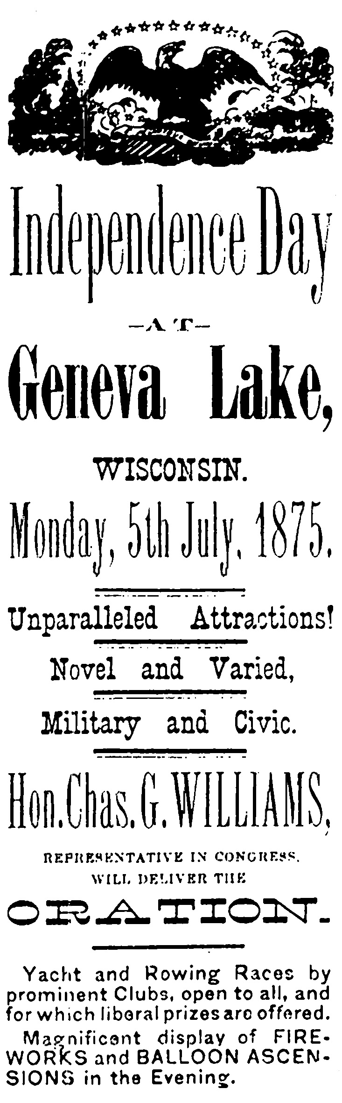

Population—Churches—Hotels—
Reaper Works--The Lake—Schools—Mineral Springs.

Correspondence of the Sheboygan Times.
As a summer resort, this place cannot be excelled by any other in the State. The Divine Power alone has given it its share of scenery, and what was left for man to do is fast being done, and in a few years our now growing village will be a city of great magnitude.
The population of this place is now about 2,000, with the present prospect, judging from new buildings which are now being erected and under contemplation, that by fall the number will be considerably increased.
The Fox river branch of the C. & N. W. R. R. terminates here and our facilities for doing that kind of business are at present very good., three trains making eight trips to and from Chicago, a distance of 85 miles. The time now required in going to town is three hours.
We have five churches here, the Presbyterian, Episcopal, Methodist, Baptist and Catholic, all of which have very large congregations.
Out hotels are all first class and are three in number, the Whiting and Lake Houses and the St. Denis Hotel. The Whiting house is on the lake shore with a fine view of the lake. It is only open from May until November and during this time a great many find shelter and are fed from the bountiful tables of luxuries spread before them. The terms are $2.50 per day. The Lake House, Mr. O. Blakeslee Proprietor, stands on the corner of Broad and Main streets. Mr.. Blakeslee is well known as a hotel man. The third , but not the least, is the St. Denis Hotel. It’s the place where you will find a well spread table and a well regulated hotel.
A stock company with a capital of $100,000 has been formed here for the purpose of manufacturing the celebrated Crawford Mower and Reaper. One hundred six acres of land and a splendid water power have been purchased by the Company. The Company has laid some of this land into village lots, and they are selling from $100 to $300 per lot.

POST NET

On Center St. One block
off of Main St. Packaging for all manner of personal items. Shipping to almost anywhere. Copy work done promptly.

Packaging & Shipping
The Lake from which Geneva derives its name and which brings so many people here is ten miles long and from one-half to two miles wide, and in some spots very deep. There are no shoals in it. Fish are abundant. Pickerel, bass, perch, suckers and the famous ciscoes, which are caught only once a year, generally between the 10th and 24th of June. They sell readily from $1 to $3 per dozen.

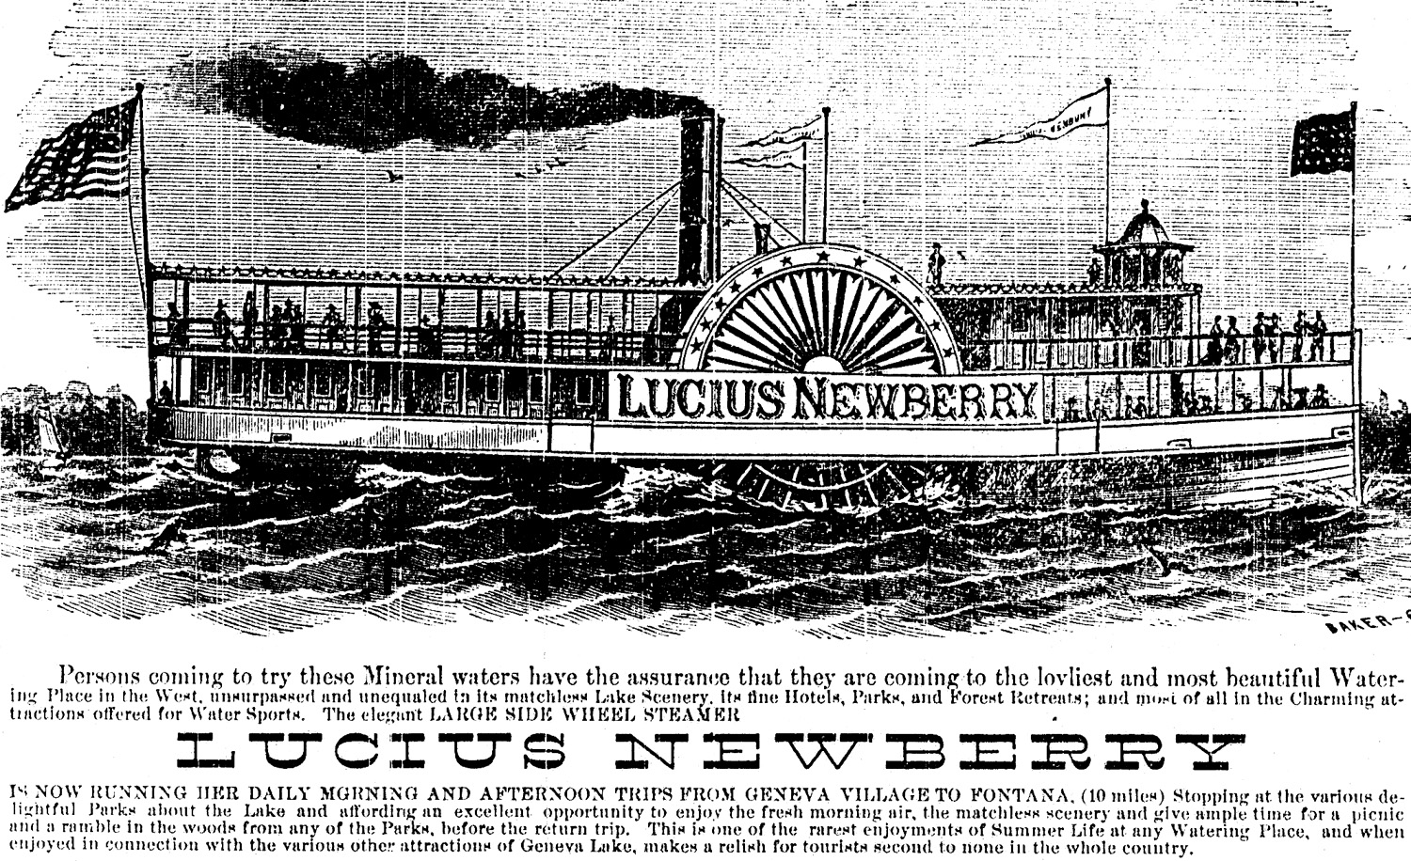
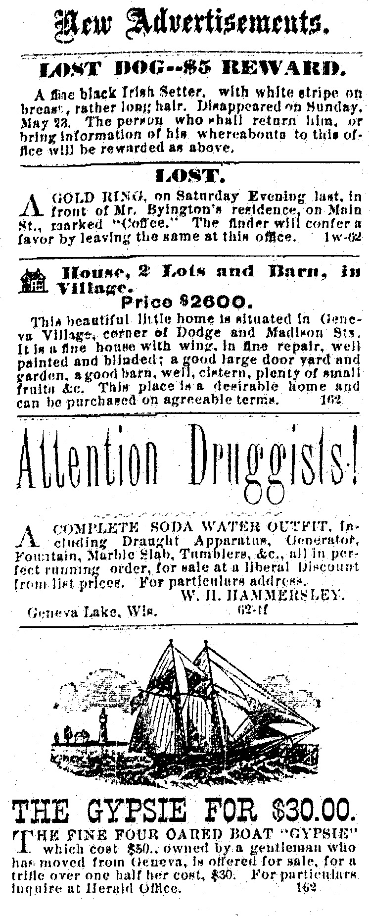

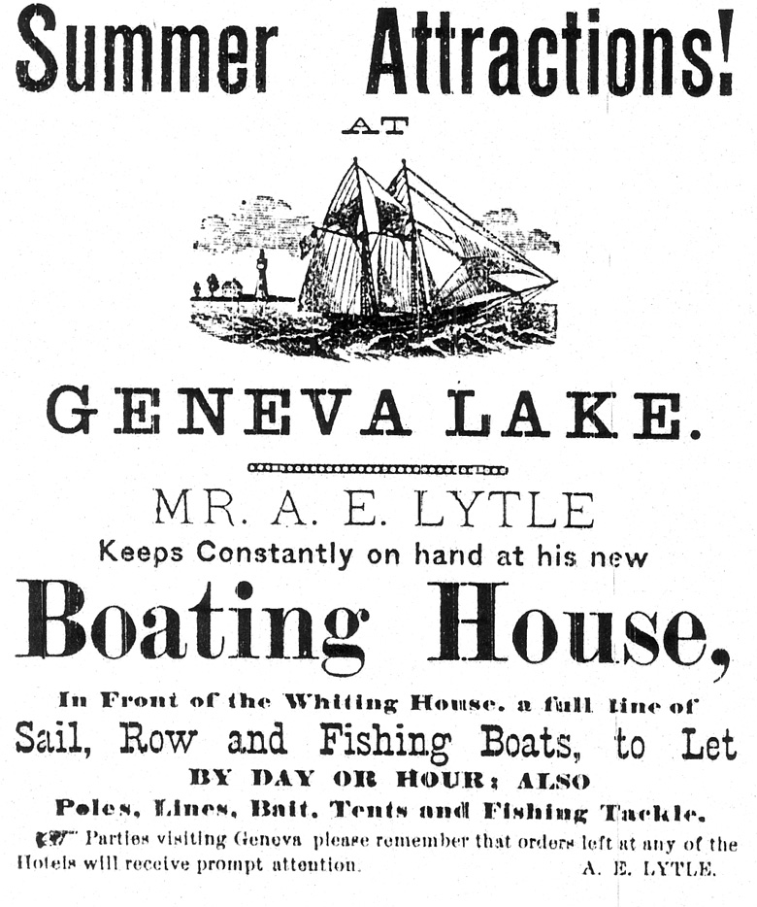
CIVIL RIGHTS.

Chattanooga – Owing to the passage of the civil rights bill, the proprietors of two of the principal hotels here have surrendered their licenses, and will conduct their establishments as private boarding houses.

A test case of the Civil Bights Bill is now on the road for decision on its constitutionality. A colored man entered Burke’s restaurant, Chicago, took his seat and ordered his dinner of a negro waiter. The waiter reported his case to Mr. Burke, who positively refused to entertain him, declaring it would injure his business. The colored man then arrested Burke for violation of the Civil Rights law and he was bound over to appear in the next session of the court.
It is one of those transactions which are performed with real manliness on both sides to the admiration of the world. The black man made no offensive demonstrations upon entering or upon leaving. The barbarous style of dealing with the black man so common in the South, was not evinced here. Mr. Burke did not have the man thrown out; no hot words, no pistols.

THE DECAY OF ROMAN CATHOLICISM.
From the Berlin Zeitung.
What was Rome in 1790, and what is it now? Within these eighty years the Church-State and the temporal power of the German Episcopate have been dissolved; possessions of the church in France, Spain and Italy have been sold as national property. Everywhere has Protestant heresy been given civil rights. Protestant chapels flourish in Rome as well as in Madrid; the Protestant clergyman walks about unmolested and disseminates his Bibles by thousands. The German Catholic movement of 1840 by no means foundered on Peter’s rock; it was first hindered then repressed and finally strangled, through police measures by State persecution.

The Lake Geneva Old Times is sponsored and financially supported by the Lake Geneva Historic Preservation Commission. Each issue represents one year of authentic old news. It is free to the public. The public may obtain copies at the Library, Grandma Vickie’s Café, Dunn Lumber, Pick-N-Save, Caribou Coffee & Starbucks. Back issues can be purchased for 50 cents each.
Editor, Denny Teichow, 262-248-6313.

