Vol. 1
No. 3
1856

In 1856 the war in Crimea ended, but here at home those pesky Indians kept resisting our efforts to take all their land. And Kansas hosted its own little war over slavery. Geneva, Wisconsin, decided to incorporate. Notice the emphasis on ships & trains, the only two means of long distance transportation available. “Cars” in the 1800’s meant railroad cars. Remember, comments in brackets [ ] are my own. D.T.

Selected Story.
One More Dress.
by Oliver Optic

“To think of wearing the same dress Sunday after Sunday!” exclaimed Mrs. Bradley, a young married lady, to Mrs Green, her mother.
“Why not, Sarah?”
“Folks will think it is the only one I have which is fit to wear to a meeting.”
“It is, isn’t it?”
“I know it but I don’t care about all the world knowing it.”
“You would not make all the world believe that which is not true, would you?”
“I don’t care – I mean to have a new silk immediately.”
“But Sarah, your husband cannot afford it.”
“Well, I don’t know; we could make our provision bill less.”
Mrs. Green shook her head.
“I don’t think there is any need of our having beefsteaks and mutton chops every morning for breakfast.”
“But James depends upon it.”
“I know it; yet for the sake of letting me appear a little better on Sunday he would be willing to dispense with it.”
“But he was brought up in the country , where he had meat for breakfast and he does not think he could make a meal without it.”
“We will not say any more about that, then,” replied the young wife, who, I beg the reader to believe, would not willingly have deprived her husband of any real comfort.
“How do you suppose Mrs. Farmer gets so many dresses? She comes out with a new one almost every Sunday.”
“I hope her husband can afford them,” replied Mrs. Green shaking her head.
[He couldn’t. The story goes forward several years with the Farmers living beyond their means and the Bradleys putting enough aside to buy the business. Mr. Farmer died a penniless drunk.]
“Sherry cobblers, a shiftless wife and ‘one more dress’ had done their work.”

THE CARS HAVE COME !

The first shrill whistle of the “iron horse” on the Wisconsin Central R. R. was heard by the people of Geneva, about noon on Thursday last, and its thrilling notes were quickly answered by the merry peals of the village bell. Quite a few of the citizens were seen “rushing to the scene of action” and were soon convinced that Geneva is bound to Chicago by “iron bands.”
In compliance with an invitation by Mr. Teft, the gentlemanly superintendent of this road, to “take the group down to Richmond and back again,” about thirty of our citizens went on board the car attached to the engine, and we started for our sister village.
As we rode along past well-tilled farms fringed with fields of luxuriant grain, we thought of the change a few short years have made. Twenty years ago this was a wilderness of groves and prairies, where the rude Indian pitched his tent, and where the wild deer roamed, but where the foot of the white man had seldom trod. But how rapid the march of civilization!
The smoothness of the road for one so new was a subject of general remark. We stopped at Genoa City a short time, and arrived at Richmond in 42 minutes from the time we left Geneva. This was pretty good time for the first trip. After staying for a short time and “watering the horse” we returned. Everyone enjoyed themselves to their utmost ability to do so.

LATEST FROM KANSAS.

Lawrence Destroyed.

Women and Children Fleeing
before the Mob

HOTEL and PRINTING PRESS BURNED.

Mr. J. Grover and Mr. G. Warren just returning from Kansas, bring us the following intelligence:
On Wednesday the U.S. posse that had assembled at Lecompton made their appearance about sunrise. They took possession of the roads leading to and from Lawrence so the citizens in town could not communicate to those in the country.
About 11 A.M. the Deputy Marshal with a posse of 9 or 10, made their appearance in the streets. They were unarmed save some small arms. The Marshal then summoned four of our citizens to assist in making arrests. The posse then took dinner at the Freestar Hotel.
After dinner the prisoners were conveyed out of town, and sheriff Jones made his appearance with a party of 18 men, did not attempt to make any arrest, but in an insulting manner demanded the arms both public and private, and said that he would give them five minutes to accommodate the demand.
*
*
*

That “Treason in Kansas.”

Much has been said about the Secret League formed by the Free State men of Kansas. An Irishman named Laughlin who was a member of the league pretended to expose its secrets to the Pro Slavery men, which led to a fracas that caused the death of a Free State man and [this trickery was] denounced by Atchison as “treason.”
The St. Louis Democrat says, “It [the deception] was instituted before the “Barons of Kansas” assembled and immediately after the illegal invasion.
Female Education.

Voltaire used to say, that all he wanted to mould the character of a nation, was to have the making of their songs. With much more truth it may be said, that the character of a people depends upon the education of their women. Wherever you find the female sex degraded by bondage or sensuality, there you find the people proportionally debased. In the East, where women are shut out from any society except the harem, the social condition of the other sex is but little better than that of the tribes of the surrounding deserts. In Southern Europe, and America, where the female mind is veiled and shackled by superstition, its influence tends to enervate and dwarf the whole population.
In our own country we have not made that progress in female education which we have in almost every branch of the mechanical arts. And yet where is there a country so dependent on its prosperity and happiness upon the character of its women as our Republic?

To Keep a Stove Bright. – Make alum water, and mix your “British Luster” with it; put two spoonfulls to a gill of alum water; let the stove be cold, brush it with the mixture, then take a dry brush and luster and rub the stove till it is dry. By two applications a year, it can be kept as bright as a coach body.

Soap Improved. – The wife of an American agriculturist has been experimenting on soap, and finds the addition of three quarters of an ounce of borax to a pound of soap, melted in without boiling, makes a saving of one half in cost of soap, and of three fourths of labor in washing, and improves the whiteness of the fabrics; besides, the usual caustic effect is thus removed, and the hands are left with a peculiarly soft and silky feeling, leaving nothing more to be desired by the most ambitious wash woman.

A Nice Way to Cook Apples. – Take a dozen apples, pare, core, and par boil them. Heat up six eggs and stir in one quart of milk. Sweeten to your taste. Pour the custard over the apples and bake for three quarters of an hour. Eat when cold. -- Baltimore Sun

The City Charter.

In talking with our citizens about the feasibility of obtaining a city charter we have found but few opposed to the measure; and their objection has almost universally been that such a procedure would increase their taxes.
The mere fact that it will increase taxes cannot be an objection to any measure for any men of sagacity [Look it up.] for no improvement was ever made in streets, roads or rivers; no canal was ever dug, or Railroad built without increasing taxation in some form or other; but all of these improvements have been profitable to those whose taxes were increased by them, because the property in which the taxes were assessed, increased in value at a rate far more than proportionate of the taxes paid on it.

SEMINOLE WAR RENEWED.

Nine Soldiers Fired Upon by the Indians – Seven Men Massacred.

We have received an extra of the Florida Peninsular which brings alarming tidings in regard to the Indian trouble in Florida. A renewal of the Seminole War is considered inevitable.
The Peninsular says: An exploring party under the command of Lt. Hartstuff were suddenly attacked at daylight about 50 miles southeast of Fort Meyers. Three men of the command arrived at Fort Meyers the following night. It is supposed that Lt. Hartstuff and the remainder of his party have been killed.
Two companies of the 21st Artillery were to leave in search of Lt. Hartstuff and his party.

Harper’s Magazine was received with its usual variety of good reading material. First, a biographical sketch of George Washington by John Abbott. Also the second part of the celebrated tale “Little Dorrit” written by Charles Dickens.
We will furnish Harper’s Magazine and the Express for one year for $4.00.

WANTED
At this office immediately, a few loads of Wood on subscription.
Patronize the Unfortunate

Homer Hobbs, a mute Phrenologist will call on the Citizens of Geneva, at their dwellings, if requested, and examine heads and give charts, or he will wait on them at the office of O. M. Baker, Esq. for that purpose. He promises that his examinations and charts will satisfy even the most skeptical. Terms moderate. Try me.
Loss of the Schooner Lewis and All Hands.

Boston. The unknown vessel which struck on Shag Rock, in Light House Channel, during the gale of Sunday last, is the schooner Lewis. She was in company in the bay with the schooner Wolcott, from New York, which arrived on Sunday Morning. The Lewis’ papers were picked up by a fisherman. The loss with all on board is considered certain.
New York.
The steamship Northern Light arrived at a late hour last night from California. She brings $600,000 in specie and upwards of 200 passengers.
Matters at Nicaragua are said to be improving.
The mines at California are yielding more abundantly than ever. Several new mines opened.
The steamer Atlantic arrived this P.M. from Liverpool. She brings London dates [newspapers]
News is interesting but not important – mostly rumors.
Estahoxy has reached St. Petersburg with the western ultimatum, but is not yet returned.
Saxony has also sent to St. Petesburg Baron Seback to recommend peace.
England demands indemnity for war losses which Russia backed by Prussia, absolutely refuses.

Donation Party.

The friends of Rev. J. H. Parks are cordially invited to attend a Donation Party at the residence of Mrs. J. Eddy in this village, on the afternoon and evening of Thursday. By the order of
Committee of Arrangements
Tarred and Feathered. – The Louisville (Ky.) Courier gives this account of the barbarous outrage of a tarring and feathering of a school teacher who, it was believed, had written letters to the Ohio Statesman in which that peculiar institution was not treated with proper respect.
The name of the victim was J. Brady and the outrage was inflicted by a mob of 200 persons. The following are the disgraceful particulars:
“He was conducted to the Court House yard and there stripped. A large quantity of pitch had been prepared for the occasion, along with several bags of feathers. The pitch was applied and the feathers were nicely planted and Brady’s head shaved close to the scalp save two locks near the forehead. He was then set loose and charged to go forth and sin no more. More severe punishment would have been administered had it not been for the wife of Brady, a beautiful and estimable lady. Brady applied to a physician to remove the tar but it was utterly impossible. He left on the morning train for Covington and the land of the Republicans.”

Correspondence of the Daily American. Geneva, Wisconsin

Messrs. Editors: - On my arrival at this place on Thursday last, I was so fortunate as to put in at the Lake House whose new proprietors have refitted and repaired the same, and made it , in fact, one of the most comfortable stopping places in Wisconsin.

Geneva
is perhaps the only “watering place” in Wisconsin. Situated at the lower end of Geneva Lake, in the midst of one of the most fertile and beautiful portions of the interior of the state. It has excellent water power with a mill thereon of four run of stone. There are some nine or ten dry goods stores in the place. Two excellent hotels, and the usual variety of carriage shops. – There are four handsome churches, good public schools and an academy. Suffice it to say that the place is “Yankee” all over – the inhabitants being nearly all from New York, and from New England.

But the Lake, the surpassingly beautiful “Geneva Lake”, now sleeping in the icy arms of winter, constitutes the chief attraction here.
Its waters are of the purest crystal. Its shores are over hung with waving boughs and twining vines, in which the forest songsters build their nests and sit and sing until the hills are vocal with their songs. And here too is the finest fishing in the world as well as hunting in the surrounding country.
Our state is adapted to become the garden of the world. And I trust that minds absorbed in the great struggle for the acquisition of property will yet become sensitive to the varieties of worldly wealth, and seek to cultivate the higher faculties of their soul by a more familiar intercourse with nature and its loveliness; and he that seeks Geneva first secures one of the clearest heritages that our “Common Father” has given to his children.
Yours, B

A Sad Accident. – On Saturday evening last as a company of 14 persons of both sexes in a wagon were returning from a lecture delivered that evening at the Genoa School House, the hind wheels of the wagon touched a saw log lying at the side of the road, which threw the driver from his seat, entangling him in the lines, and drew him beneath the wheels, crushing his lower jaw, and causing other serious injuries about the head.
The horses took fright, -- dashed off at a fearful rate, tore the wagon to atoms, causing slight injuries to almost everyone aboard.
The driver’s name is Henry Petitt, a steady, cautious, skillful horseman. He is doing as well as can be expected. Whilst he is seriously injured, his life is not despaired of.

Writing School.

We are happy to announce to our readers that Mr. Bennett has arrived and will commence a course of 12 lessons in writing on Monday evening next at Parks Academy. His system of penmanship stands unrivaled for ease of acquisition or beauty of style. He soon transforms the most scrawling, cramped and awkward hand into an easy and masterly style of penmanship. Specimens to be seen at the Post Office. Terms $2.00 per scholar for 12 lessons, books included.

“Men are getting richer faster, and living higher and doing more business, and drinking more, and going to the devil by a shorter road, in Chicago than in any other place I have seen out West.” - Wisconsin Democracy

The Editor of the Woonsocket Patriot makes merry over a mistake of an old hen of his, that has been “setting” for five weeks upon two round stones and a piece of brick ! “Her anxiety,” quoth he, “is no greater than ours to know what she will hatch. If it proves to be a brickyard, that hen is not for sale.”
Fire. – The frame dwelling of Joseph Howe, in the south part of this village, was burned to the ground on Wednesday. Fire supposed to have caught from a stove pipe. The furniture in the lower part of the house was saved.
There was nothing of importance doing in Congress, Saturday. [Gee, imagine that.] – The house passed one and rejected another private bill. The senate was not in session.

To Our Patrons.
The present number of the Express closes the first half year of its existence, and with it our connection with the paper terminates. – We have “sold out” our entire interest in the establishment to Messrs. F. Leland and Geo. Utter, who are t o be our successors. We cordially bespeak for them a continuance of the patronage that has been so liberally extended to us.
We are pleased that our bantling has fallen into so good hands, and we trust that the little craft will sail smoothly over the sea of public opinion.
We have every assurance that the Express will hereafter advocate the soundest morality, and let the people know that there is such a place as Geneva , containing 1200 souls, that you have the most beautiful location that nature ever designed for a village and that you are soon to become a city and be know as such to the world.

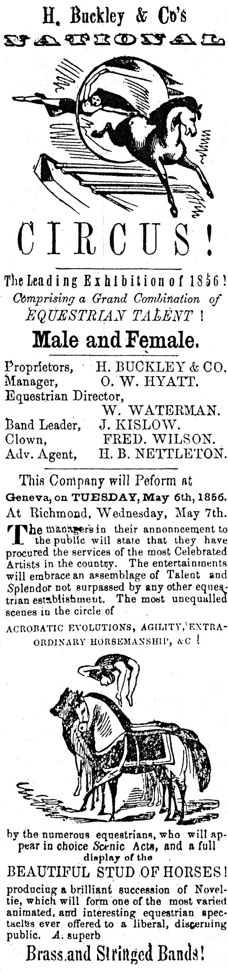

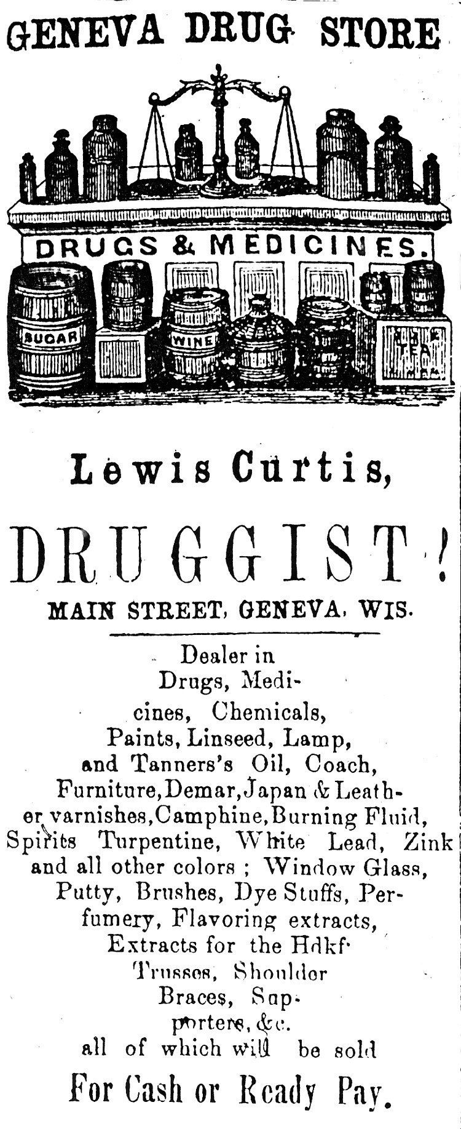

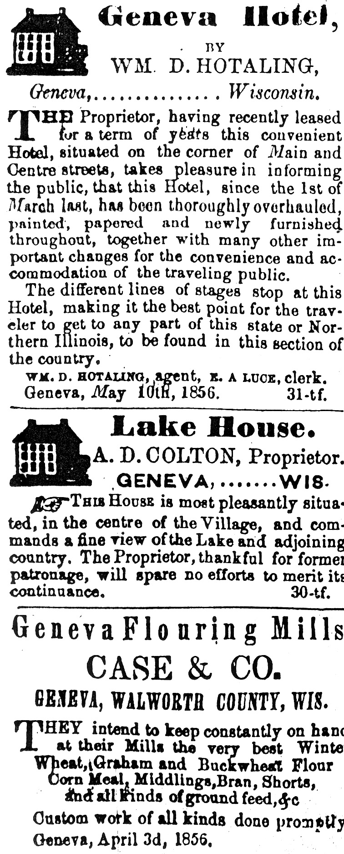
AN ACT TO INCORPORATE THE
The Lake Geneva Old Times is sponsored and financially supported by the Lake Geneva Historic Preservation Commission. Each issue represents one year of authentic old news. It is free to the public. The public may obtain copies at the Library, First Bank, Grandma Vickie’s Café, Dunn Lumber, Pick-N-Save & Starbucks. Back issues can be purchased for 50 cents each.
Editor ,Denny Teichow, 262-248-6313.

VILLAGE OF GENEVA.

THE PEOPLE of the state of Wisconsin, represented in Senate and Assembly, do enact as follows:

Section 1. All that district of country in section number 36, the south half of section 25, the southeast quarter of section 26 and the east half of section 35, in township number two, north of range 17, east of the fourth principle meridian, and all being in the town of Geneva, County of Walworth shall hereafter be known and distinguished by the name of the VILLAGE OF GENEVA. [yada, yada, yada for a full page, including details, such as…]

13.7 To restrain the running at large of cattle, hogs and all other animals, and appoint pound masters and fence-viewers.

13.11 To suppress disorderly and gaming houses and devices for the purposes of gambling.

13.14 To tax every male residence of said Village above the age of 21 years and under the age of 50 years, two days labor or in liew thereof, two dollars to be appropriated in improving the roads and streets of said Village.

Prepared for the Holidays. – Messrs. Phillips having ascertained that the holidays are close at hand, have been to the expense and trouble of going clear to Milwaukee for a whole lot of Toys, to please the little folks. They may be seen at their store. If “Santa Claus” doesn’t replenish many a little stocking with them it will be a wonder indeed.

Merry Christmas to all from the Historic Preservation Commission and the “staff” of the Lake Geneva Old Times.

