Vol. 1
No. 10

1876

Devoted to Progress and all that Makes Humanity Better


July 4, 1876 was the 100th birthday of the United States of America. Geneva, Wisconsin was into its 4th decade and growing rapidly. Temperance was still a big issue. The Herald has been taken over by two fellows named Heg & Waterbury. Remember, comments in brackets [ ] are by me. DT.

Opium – Its Effects, Good & Evil.
Lecture Delivered by Dr. D. H. Trimble in Walker’s Hall.

Published by request.
I shall speak to you of a little flower, a common flower of some beauty. I allude to the Poppy. This flower which you are growing in your gardens is endowed with properties of vast and varied power, and according to the manner in which they are used, instruments of great good, or of great evil. And so it is with many of the creations of the Almighty. He makes them for our happiness and by our sins we pervert them to our sorrow and our destruction..
The Poppy derives its importance from being the source of one of our most potent and useful narcotic medicines, Opium. The Poppy is a native of Asia and is largely cultivated for its Opium in India, Persia and Turkey. Successful efforts have been made to cultivate it in Kentucky and Tennessee, and I believe it could be raised as far north as Wisconsin.
Opium can be smoked or ingested. After a time a quiet calm steals over the senses, pleasant, sometimes brilliant or fantastic thought or dreams occur. As its influence passes off and the person awakes, feelings of depression, of nausea and of headache succeed. In nearly all diseases where there is pain, Opium and its active principles are indispensable aids. How many prostrate and suffering forms have been refreshed and invigorated by it! In nothing is its beneficence more marked than in those hopeless and painful diseases, cancer and consumption. To such sufferers what a blessed boon is Opium!
That Opium has a pleasurable and fascinating effect upon the mind and senses, for a certain time, is undeniable, and many will submit to the subsequent sufferings, for the sake of the transient pleasure. Its effect is not so much to intoxicate as to numb the faculties; its ultimate effect, unlike those of alcohol, being quieting instead of exciting. With prolonged use its powerful effects upon the constitution are manifested by the stupor, forgetfulness, deterioration of the mental faculties, emaciation, the appetite being either depraved or destroyed.
HERALD READERS’ QUERY BOX.

By J.H. – Springfield – How many men do the Crawford Works employ., and are they in need of more?
Ans. – The Crawford Works at present employ forty men, and will probably increase their force to sixty by the expiration of sixty days. The want of the works now is skilled workmen – and it will be of no advantage for others to apply.
By J.D. – LeRoy, Minn. – Why is it that continuous firing of guns of heavy caliber, will nearly always bring on a thunderstorm?
Ans. – The cause of rain is the change of atmosphere. Sudden changes bring on severe thunderstorms and gradual changes bring on gradual storms. This rule is universal and without exception. Many have tried to explain the fancy that firing of guns produced storms, but it is our opinion that very little difference is caused in the conditions of the atmosphere. One volume of gunpowder will give off 1,800 volumes of gas, mostly nitrogen, with but little moisture. This gas being hot will take up a good portion of the water in the air and then rise into the upper atmosphere where it will cool and a fall of water is a natural result. Now, the question is whether this mechanical change is extensive enough to cause rain. It is our opinion that it is not.

Extract from Beecher’s Sermon on “Rest.”

The puritan Sabbath, as it existed in the early day, had a certain propriety in it. The Puritans were driven away from others and there was a reason why they should concentrate in the Sabbaths and make them, in effect, fenced cities; but that reason has passed away; and yet the customs of the old Puritans has come down through posterity, and we have Sabbaths on which men rise early, go to family worship, then to Sunday school, then, after a short meal, go to public worship, then to a prayer meeting, and then to evening church. To men who pursue such a course, the Sabbath is a day of bondage.
There is a certain necessity for every man, woman and child to have a part of Sunday for himself. Every Sunday ought to have some hours in which you obey the words of Christ, “Let us go apart for a little rest.” Soul rest, spirit rest and heavenly rest is a necessity for every one.
[Henry Beecher was the Billy Graham of his day.]

The Herald

BY HEG AND WATERBURY

Gold in New York yesterday $1.12.

Chicago has a new council and is happy.

The Grand Jury has indicted General Belknap for accepting bribes while Secretary of War.

It is reported that the Red Cloud and Spotted Tail Agencies are out of supplies and that trouble is apprehended from these tribes.

Another story implicating James Blaine with the Kansas Pacific R. R. and asserting that he received bonds in return for services in Congress, has been exploded during the past week.

Cuba is in trouble again. The insurgents have destroyed by fire five more large estates, the wealth of which consisted mainly of sugar and tobacco. At this rate Cuba will soon be so far used up that it will not be worth fighting for.
[Fighting in another country for our financial interests; an American tradition.]

THE CENTENNIAL ARCH
July 4th
1776
1876

by John Kaye

Today fair freedom’s arch perfects a span,
The grandest ever granted unto man.
The most substantial since the world began,
The pride of every American.

A hundred years ago its curve ascended!
Today ‘tis finished and the first arch bended
Of a grand bridge we hope may be extended
‘Til all wrong is righted, all error mended.

A century since, old Independence Bell
With iron tongue proclaimed the joyful news
With startling clangor and vibrating knell
For anarchy had made the country choose –
For Freedom was their watch word, and afar
Through smoke & strife they saw Columbia’s star
Arise slow soaring through infinity
And flashing forth the light of liberty
‘Til peace came in, ushered by victory

Benign peace, sweet tranquil peace
All hail the day when war shall cease.
REPUBLICAN TICKET.

For President,
RUTHERFORD B. HAYES,
of Ohio.

For Vice-President,
WILLIAM A. WHELLER,
of New York.

WISCONSIN NEWS.

There are fears of a flood around La Crosse.
The Wisconsin State Turnerfest will be held at Plymouth in July. [“Turners” were gymnasts.]
Die Racine Post is the name of a weekly German paper just started in Racine under the auspices of some prominent citizens of that nationality.
Editor Coe, of the Whitewater Register, met with a fearful fall a few days ago. He has fallen heir to $63,000, and still he is not proud. Printers are a class that such little happenings don’t spoil.
A young man named Antisdel was nearly killed at his father’s farm near Janesville on Sunday, by a vicious bull which charged on him as he was leading him out of the barn. The animal pushed him clear through the side of the building.
The Mexican Diario declares that if the United States “invade Mexico on any pretext, the government will defend the soil with energy,” and the Chicago Times adds, “The solicitude of the Mexican for his native soil is so great that he habitually carries a large quantity of it around with him.”

Centennial Items.
[at the centennial fair grounds]

Pretty girls at the flower stands in the Main Building, importune you to purchase just as they do at church fairs.
The log cabin contains only one hundred year old things, and one might spend that much time there in pleasure and profit.
Specimens of wooden nutmegs asnd wooden hams, made from “Charter Oak” are exultingly exhibited in the Connecticut reception room.
The guide book men and boys are a fearful nuisance, and only a few know enough to give back sufficient change. Beware of ‘em!
Memorial Hall is the place for flirtation, and it is funny how quick the fact was discovered by those who are fond of that centennial recreation.
The Corliss engine must be seen to be appreciated. It is wonderful in size and noise. The man who sits underneath it is understood to be deaf.
One of the best lessons of the Centennial is the honor it confers upon all kinds of labor, like the labor of finding hotel accommodations. – Detroit Free Press.

The Crawford’s Success in the Field.

The ingenuity of America, the most inventive of nations, has been the theme of many a discourse. Nearly all the great inventions have either originated in or been greatly improved in our country, but in no one machine, excepting perhaps the sewing machine, have such wonders been accomplished as in the improvement of reapers and mowers.
Nearly every machine, however, will do what is required of it, and its superiority over another consists mainly in its ease of management, draft, and general make up; and these are the points in which a variety of opinions exist.
The establishment of the Crawford Reaper & Mower works in our village has caused us to give a little more attention to the subject of Reaper Manufacture than we would otherwise, and a thorough examination has convinced us that the machines made by this Company are truly excellent, and it is with pleasure that we hear of its brilliant achievements and success.
It is the Herald’s duty to support and aid in every possible way any enterprise of Geneva, and we feel it is no more than a duty to refute the slanderous words of rival agents and persons envious of the prosperity of Geneva’s main manufactory. Because the works are discharging men, it is said by persons opposed to the company, that it is on its last pegs and will soon go to smash, when those very same persons know that every manufactory of farm machinery shuts down for a few weeks every summer to take account of stock and to get ready for the coming campaign. J. I. Case shut down for repairs every single year , but there is no sign of their closing.
Compulsory Attendance
from the Super. of Public Instruction in Wis.

The experience of another year in other States where compulsory attendance laws have been enacted, confirms in the fullest manner, my conclusion that this is not a good plan.
The compulsory education law enacted in New York does not seem to work as well as anticipated. The nine officers appointed to execute the law draw salaries amounting to $14,000. Out of 15,000 children known in January to be truants, 356 have been thus far compelled to attend school.,
It can hardly be questioned that compulsory legislation is now substantially a proved and admitted failure in every State in which it has been tried. It will be doubtless but one or two years before its friends everywhere admit this.

Fourth of July.

The citizens of Geneva convened on Tuesday at the office of C. L. Oatman, to consider the propriety of celebrating the coming Centennial Fourth of July at peace.
The evening was long and enthusiastic. J. A. Smith was elected Chairman, and a general committee was elected.
It appears that everyone is bound to make the Fourth of July in Geneva a day of more than ordinary interest. Look out that you keep posted and don’t get slighted by the committee.

MARRIED.
DOW-DUNBAR – by Rev. Hammond at Sharon, D. B. Dow and Sophie Dunbar.

MARSH-SEAGER – by Rev Brill at Sharon, Chas. F. Marsh and E. Amanda Seager/

DIED.
MILLARD - in the town of Linn, Julia M. Millard, aged 29 years, 6 months and 8 days.

Letters remaining uncalled for in the Post Office Geneva, Wis., June 15, 1876.
McCaughey, John; Kingsley, M. C.
Smith, Master Frank; Woolcot, Mrs. Ella



The new lumber yard is now ready to supply all kinds of building material on short notice. Although most men seem to be convinced that the old yard was a splendid place to deal, and no better accommodations could be wished, yet by the presence of two yards, they will be a little more positive that Geneva can’t be beat by any other village in the county as a place to buy lumber.

When you see a man that shuffles loosely along, with his knees knocking together – whose eyes roll furtively and whose hand is ever suddenly jerking itself above his head as if warding off a blow, you can rely on it that that man is haunted by his mother-in-law. But when you see a party who lifts his feet high, and holds his nose in the air, and whose mouth is distended with a self-complacent grin, and who seems to feel good all over, you can bet your last cent he has just bought a new “Domestic” sewing machine for his wife.

Several counterfeit bills have been detected in circulation in Geneva within a few weeks; and from the very suspicious circumstances under which they appeared, we should say that it would be just as well for those who brought them to save their money, in the future, for some other town, as they might be caught here. They can be assured that they are spotted and their money will be watched when they appear in Geneva again.

Nearly every paper in the State, in mentioning the change in proprietors of the Herald, have wished all manner of success to the new firm. We thank you for your kind expressions of regard, and hope that time will afford the opportunity for an acquaintance with each and every one of you.

New Advertisements.

FOR SALE CHEAP.
One No. 1 Excelsior Hand Lawn Mower, cutting 12 inches wide, and one No. 3 Excelsior Hand Mower, cutting 15 inches wide, for sale at the Herald office. Cheap.

CARD.
Those pupils wishing to join Anna Belle Fellows “Juvenile Singing Class” will please to be present at the opening of the term, commencing July 6, and continuing ten weeks. Hours for instruction from two to four each Tuesday and Thursday afternoon, at her residence corner of Wisconsin and Warren streets. Tuition $2.50 per term.

ESTRAY.
Strayed into my enclosure, in Linn, Walworth Co., Wis, on or about the 8th day of June, 1876, two dark bay colts, one a two year old mare , the other a yearling colt. Owner can have same by calling at my residence, proving property and paying charges.
S. J. Nichols.

Summer Fashions for 1876

Common Sense is worn quite short and plain, which is fortunate for most people because the material , though strong and serviceable is quite expensive.
Economy is wider at the top and narrower as you go down.
Candor is cut the straight way of the cloth, so it looks a little stiff. It is generally confined to the inhabitants of the rural districts, or, if brought in by the city dealers, is purchased for home wear only.
Honesty is cut on the bias this spring, so that it stretches almost out of shape sometimes in the wearing.
Intellect is much sought after in certain shops, where it is supposed to be found. A “shoddy” article is often pawned off on the shoppers, a quality with a cotton back and a satin figure. But those desirous of purchase can always find the genuine article, and it is within the means of the poor.
Fraud, though not as popular as last year, is often worn as a negligee by those retiring into bankruptcy and at the reception of creditors.
Another garment shown at the openings which promises to be as great a favorite as ever, goes by the common name of Love. Many who have purchased say it can be turned and made over for another season. There is some counterfeit on the market. It requires a practiced eye to detect the false product..

Temperance Caucus.
The first Caucus was held in Walker’s Hall. On a motion J. E. Burton was called to preside as Chairman, and Geo. Sturgis appointed Secretary. Voted that the meeting appoint a committee of three to draft a set of resolutions to the expression of our wishes to the gentlemen that may be nominated on this ticket, which resolution was written and now read by the Chairman.
Whereas, we residents and voters of the Village of Geneva, Wis., in Caucus assembled, desire to express our wishes relative to the officers of this Village, for the ensuing year, therefore
Resolved. That we wish the men accepting the nomination of this Caucus, to do so with the understanding that they are not only to not grant license, but to use all lawful measures for the suppression of the sale of intoxicating liquors.

The warlike Sioux seem to have made their preparations for a warm reception for the white troops. One train was attacked about half way to the Missouri River, only four escaped. It is thought that these Indians came from the same band that attacked Custer.

Geneva’s New Opera House.
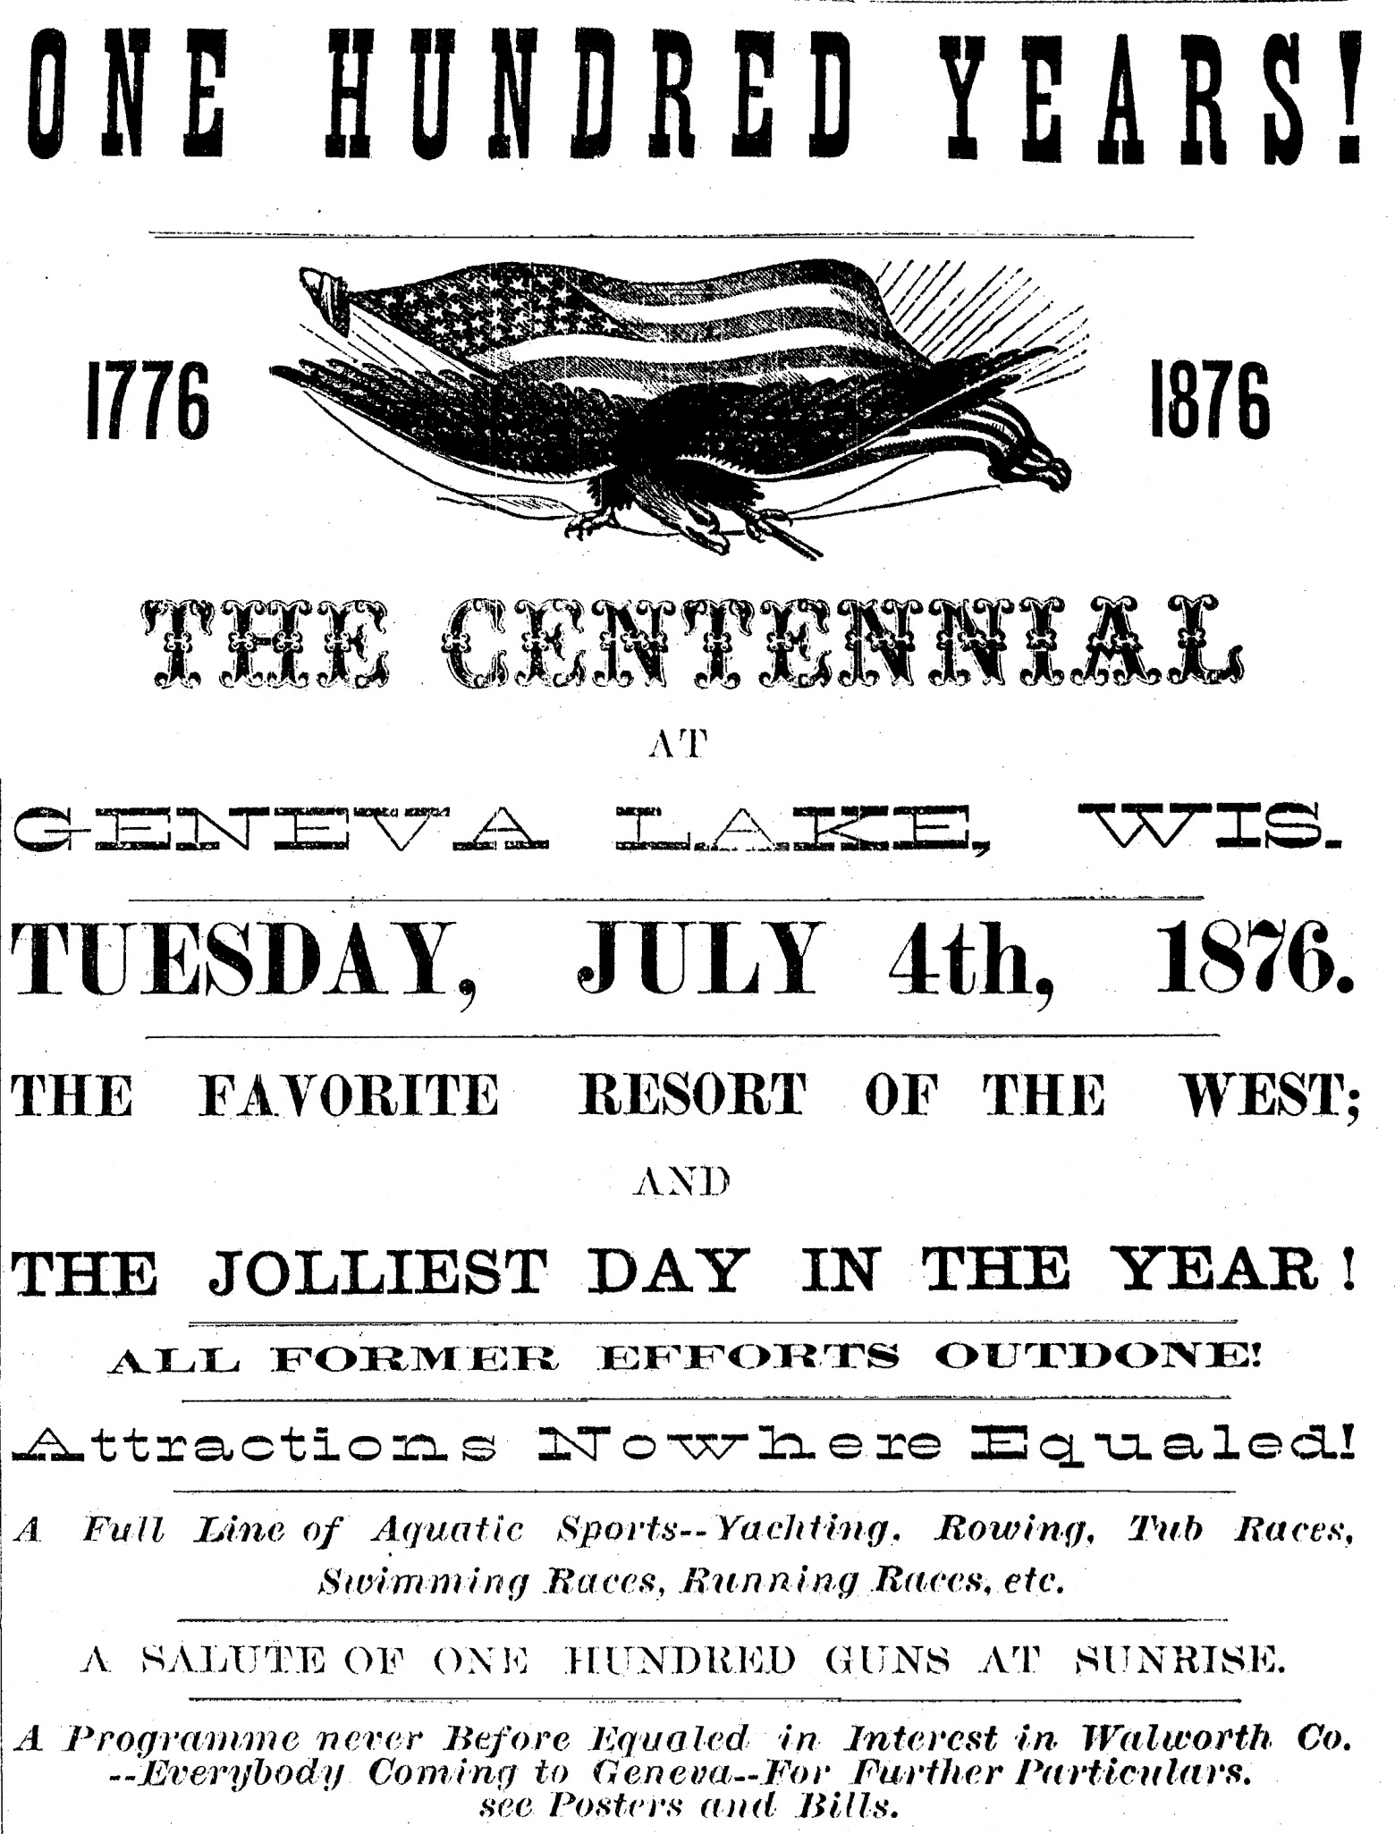

The building will be located upon Broad Street where the house now occupied by A. C. Hogaboom stands. It will be 36 feet front by 100 feet deep. The walls of the building are to be 30 feet high, and a central dome which will reach a height of 61 feet. The room inside will be divided as follows: First story will be divided into one room 50x34 feet, to be used as a great hall, and a cook room 14x16 feet, besides the rest of the space to be used as seems best. The second is to be 65 feet long by 34 feet wide aside from the stage and 18 feet to the ceiling. In front of this hall will be a vestibule 14 by 10 feet square and a ticket office 1o feet square. In the third story there is to be an audience room64x34 feet and two rooms about 15 feet square, all of which will probably be used by The Masonic Lodge, which have already contracted for them.
The name of the building has not been fully determined, but it is to be built by Miss Cornelia Ford of this place. The architect is the well known Mr. Peter Gomery.

A Hundred Years Ago.
One hundred and ten years ago there was not a single white man in what is now Kentucky, Ohio, Indiana or Illinois. Then, what is now the most flourishing part of the United States was as little known as the country in the heart of Africa itself. It was not till 1776 that Boone left his home in North Carolina to become the first settler in Kentucky. And the first pioneers of Ohio did not settle till twenty years later.

Around Town.

A party of picnicers from Delavan visited our town last Tuesday.
Willie Reynolds left for the Centennial this week.
The past week has shown more dust than ever, but no street sprinkler.
Do not forget that the annual Sheridan Regatta takes place two weeks from today.
A dancing bear and singing Frenchman were picking up pennies in Geneva last week.
Henry Cone has bought a Crawford lot of J. E. Burton and is now putting up a new house.
Mr. R. C. Parsons has fitted up the place formerly owned by Wm. Veley, and is prepared to take boarders at reasonable rates. Ice cream will be furnished at this place every Saturday evening.
On a farm out in Bloomfield eighteen rattlesnakes have been killed during the harvest. Must have been fun to bind there.


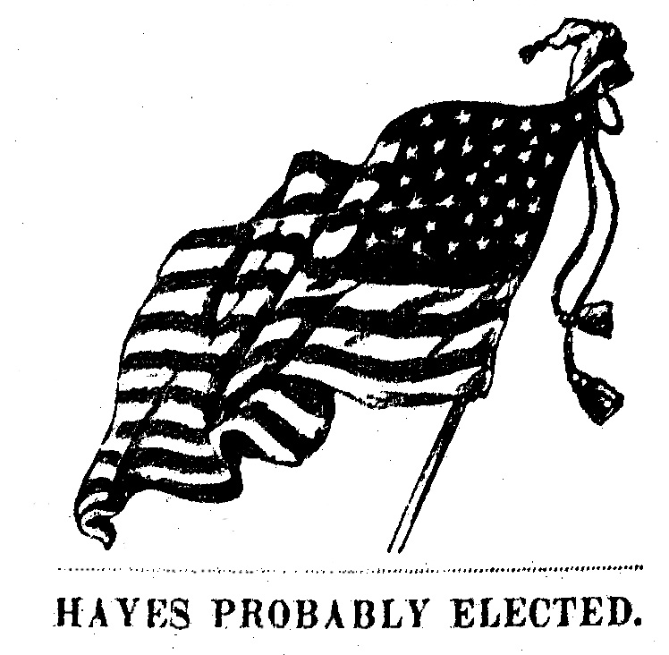
The Lake Geneva Old Times is sponsored and financially supported by the Lake Geneva Historic Preservation Commission. Each issue represents one year of authentic old news. It is free to the public. The public may obtain copies at the Geneva Museum, Grandma Vickie’s Café, Dunn Lumber, Pick-N-Save, Caribou Coffee & Starbucks. Back issues can be purchased for 50 cents each.
Editor, Denny Teichow, 248-6313.

