Vol. 2
No. 6
1884


Geneva, Walworth County, Wisconsin

Every month I find loads of interesting articles in the old newspapers at the library and can only use a small sample of them. If you really enjoy this kind of stuff, go there and ask to see the old newspapers on microfilm. It's easy. They'll show you how.
The Lake Geneva Historic Preservation Commission, the organization that sponsors and subsidizes this publication, has a website filled with useful and interesting information. Check it out at historiclakegeneva.org
And if you think the media's focus on bad news is a new thing, read on.
Enjoy. D.T.

CHRONOLOGY.
A Record of the Notable Occurrences of 1883.

January.

4. Four men killed at Muskegon, Mich., and three at Black Horse Landing, W. Va, by boiler explosions. United States Senate passes Civil Service Reform bill.

10. Burning of the Newhall House, Milwaukee, nearly 100 lives lost.

17. Eight people killed by a boiler explosion on a steamer in Port Susan Bay, Pacific coast. Meeting of National Republican Committee at Washington.

19. Steamer Cimbria sinks in German ocean, nearly 400 people drowned. Forty people killed by a powder explosion at Mulden, Holland.

23. The French cabinet resigns in a body. A mother in Milwaukee murders and carves into pieces her three little children.

February ...

March.

23. Six men killed in a fight between cattle herders in Arizona. Indian outbreak in Arizona; several people slaughtered.

29. Count Von Szekhely, President of the Hungarian Court, murdered.

April.

1. Six persons killed by a boiler explosion on the steamer Polar Star, Mississippi River.

2. Fifty people killed by the explosion of a powder factory near Paris, France.

12. Prohibition defeated in the Connecticut legislature. Earthquake shocks in Southern Illinois. Wisconsin's first cotton factory opened at Sheboygan Falls.

13. Six negro children poisoned to death at McDermott, Ark., and three burned to death in Grant Co., Ark.

21. Bloody fighting between citizens and circus men at Dover, Del.
May.

1. Four men killed in a riot at Marshall, Tex.

3. Seventy Chinamen drowned by the wrecking of the steamer Grappler on the Pacific coast.

June...

July.

18. Frost in some sections of Iowa.

24. About eighty people drowned by the giving way of a steamboat pier near Baltimore, Md. Hardy, one of the Polk County (Iowa) assassins, executed by a mob.
25. Eight colored people drowned at Claremont, Va.

29. Ten colored people drowned at Mayersville, Miss.

30. President Arthur leaves Washington on an extended Western tour.

August.

3-5. Heavy failures in the leather trade in the New England cities.

6. Serious revolt in Spain. Formidable anti-Jewish riots in Russia and Hungary.

9. Four Irish dynamite conspirators sentenced for life at Liverpool.

11. Burning of the Kimbal House, the largest hotel in the South, at Atlanta.

17. Seven persons killed by a railway collision at Lexington, Ky.

23. News of a fearful massacre of Indians by Chileans in Peru. Completion of track laying on the Northern Pacific railroad.

28-30. Volcanic eruptions in the Island of Java cause frightful destruction of life and property; upwards of 100,000 people killed.

*

*

[Well, you get the idea. I didn't just pick out the bad stuff; this sample is typical of the entire article. Observations: Apparently Southern Negros couldn't swim as well as their Northern brothers. The volcanic eruption near Java was the island of Krakatoa. It was the loudest explosion in recorded history. Check it out on the History Channel in March on their How the Earth Was Made series.]
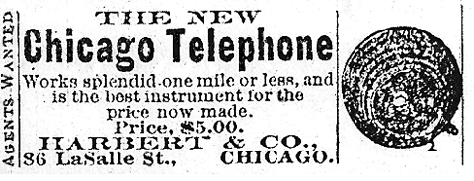

NECROLOGY.

A List of the Distinguished Dead of 1883.

January.

3. Dr. Warren Stone, eminent physician of New Orleans. Rev. Titus Coan, noted missionary.

7. Wm. A. Seaver, editor of Harper's.

9. M. C. Campbell, of the original Campbell minstrels.

12. Dr. A. Samuel Mudd, of Lincoln assassination memory. [ After the assassination he fixed Booth's broken leg and failed to notify the authorities.]
24. George Judd, the oldest practicing lawyer in Wisconsin.
February.

8. Hon. C. H. Slocumb, author of the Nebraska liquor law.

9. Wm. E. Dodge, millionaire merchant and philanthropist of New York.

15. Richard Wagner, the celebrated German composer.

16. Dr. Hugh Glenn, of California, the largest farmer in the world.
*
*

July.

8. Marie Von Elsner (mlle. Litta), the prima donna.

14. Charles H. Stratton (Gen. Tom Thumb), the famous dwarf, aged 45.

September.

4. Marwood, England's professional hangman.

12. Pellis Manny, of Moline, Il., inventer of the Manny reaper

29. Diana Colphus, of London, Canada, aged 115 years.

*

*
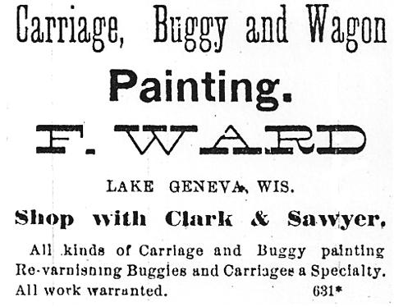

WISCONSIN STATE NEWS.

Distinctly married folks' dances are held at Oshkosh.
~
At Ahnapee, cord-wood has not been so cheap for years as iit is at the present time. Dry sawed maple goes begging at $3 per cord.
~
A family by the name of Sorernson, living in the town of Waupun, in what is called the Norwegian settlement, are severely afflicted withdiphtheria. Of the family of father, mother and seven children, all except the father were sick at the same time. Four of the children have died.
~
No satisfactory reason seems to be forthcoming for the increase of insanity in thinly settled communities like Wisconsin, where there is plenty of food and out-of-door life and comparatively little excitement. According to Mr. H. O. Wright, who has just finished formulating the Wisconsin statistics on that subject, there are at present 2,565 insane people in that State, an increase of more than 200 percent over the number given in the census of 1870.
~
Six new cheese factories are being erected in Calumet county.
~
Wisconsin paid during the past year $10,000 in bounties for wolf and wildcat scalps.
~
A. L. Tenns, of Cold Spring, Jefferson county, has a hen turkey 12 years old that has brought him $125 in cash, for the twelve broods of young turkeys which she has raised.
~
The legal complications in the estate of the late S. H. Page, of Milwaukee, who left property valued at $200,000, are so many that thus far his widow has received but $1,800 and is almost destitute of means.

William Kuhl, of Metamora, Ill. has flied a complaint in the Circuit Court, demanding$25,000 damages from ex-Sheriff Rugee for alleged false imprisonment in the Milwaukee county jail, under the supposition that he was the notorious outlaw Lon Williams.

THE TRAGEDIES AT YAZOO.

Little Doubt that the Trouble Was Purposely Caused by Whites.

The Assassination of Dickenson by Barksdale

Free Speech an Obsolete Privilege

Investigation Demanded.

Letter from Yazoo, Miss.
The recent bloody events here have struck with horror the whole country. That a state of things exists here bordering upon savagery is apparent to everyone. Colored men, like bleeding stags, have turned on their oppressors and rended them. White men, turned to fiendish brutes, have glutted themselves with deeds that make the blood run cold.
Recently a terrible affray took place, resulting in the killing of three white men and the killing was done by colored men, who have since been shot or hanged by the infuriated mob in the most cold-blooded and fiendish manner.
To persons who are unfamiliar with the state of affairs that has existed in Yazoo City since 1875, it might appear that these colored men were murders and have suffered a just retribution. But it strikes one quite differently who is conversant with Yazoo history for the eight years past.
It is evident that the Poseys and their friends were the aggressors, and that they brought about their own destruction.. It would seem that some fancied offense was given by John James, colored, to one of the Poseys. Some say that a firecracker was thrown down in front Posey by James. Another account says that two colored men were fighting in a saloon and that Posey undertook to have them arrested. But all accounts agree that no shooting occurred until some time later. Posey then went off, assembled his friends and returned armed to the scene of the difficulty. This shows clearly enough who provoked the difficulty and what party was acting strictly on the defensive. Negros in Yazoo do not carry guns, and will not get one to use except when driven to the wall. Since the bloody scenes of 1875, every white man here has been armed against the colored man. For a colored man to shoot a white man or even insult one, was to court certain and speedy death.

HUMOROUS.

-- A confirmed bachelor was out at a social gathering the other evening, where he was so unfortunate as to become seated behind a party of vivacious young ladies. Conversation turned upon athletic subjects, when one pert young miss inquired, "Mr. Brown, what is your favorite exercise?" His rather curt reply was, "Oh, I have no preference, but just at the present I should prefer dumb belles."
--Chicago Times.
-- Johnny came home from school the other day much excited. What do you think, pa? Joe Stewart, one of the big boys, had an argument with the teacher about a question in grammar." "What position did he take?" "His last position was across a chair, face down." --Detroit Post.

Double Delight.-- "It would delight me to know when you will pay me," said a creditor to Murphy.
"Yes, no doubt," replied Murphy. "And it will delight me still more to know when I shall be able to pay you."
Texas Siftings.

The word "cops" as applied to policemen is said to have originated from the copper badges they were first given to wear under Fernando Wood in New York.

BRIEFS.
A car-load of Mormon converts left Chattanooga last week for Utah.
Every communion Sunday Mrs. Annie Gordon of Bluffton, S. C. walks four miles to church. She is 111.
Young Mr. Ryan, of Atlanta, Ga., climbed three flights of stairs to whip an editor, and was thrown out of the window, nearly killing him.
It costs $22 per hour to light Iowa's new Capitol.
Street-car drivers in Memphis are petitioning against Sunday travel.
The State Fair Locating Committee of the State Agricultural Society will meet at Madison to receive propositions from cities in the State desirous of securing the annual exhibition.
Robert Bailey, a colored citizen of Toledo was found guilty of marrying a white woman and sentenced to three months in jail.

The Herald.
LAKE GENEVA, MARCH 1884.

If anybody, owing us anything, really desires to pay us, we shall be tickled half to death, for money, of late, has been scarce as hen's teeth.

The Episcopal Society enjoys the hearty pleasure of being entirely out of debt. The "Pink and Blue Tea" entertainment cleared just enough to wipe out the last vestiges of indebtedness.

The almanacs say that this is spring--gentle spring, but the thermometer is yet below zero, three feet of ice cover the lake and the ground is frozen from Oshkosh to Kalamazoo.

The Lake Geneva Herald refuses to publish amateur poetry--so called--and e think the Herald is very sensible. Few people there are with anything like a due appreciation of such stuff. --Burlington Free Press.

The Owl Club party on Tuesday evening , the last of the series, was a glowing success. Over fifty couples were present which, for a private party, was very good.

Work on the asylum building was taken up again on Tuesday morning and it will be pushed now until completion. Seven pressed brick layers came up from Chicago on Monday, and several others have come since then The common brick workers are hired from this vicinity as much as is possible.

The dance at the Opera House on Washington's birthday was all that could be desired in every respect. There were nearly one hundred couples in attendance and all enjoyed themselves immensely. The managers, C. E. Gavin and M. Hickey, proved that it is possible to to give a public dance and still have it select and a pleasure to attend.

A couple of full grown men, in discussing a certain article in the Herald last week, got to fighting over it and in the matinee that followed one of them had seventeen kinds of sawdust knocked out of him besides getting his eye badly gouged.

A new word has been invented. It is "mugwump" and it refers to a big man - in his mind - in a little place, who labors under the impression that his place is a big one and he fills it.

Abbott has a large regulator in his window, marking the new standard time from 1 to 24 o'clock. It is quite a curiosity as the motive power of the hands cannot be seen from the outside.

The First National has received its new currency and is issuing crisp new five and ten dollar bills. The bill is of the issue having Garfield at one end and is a very neat and clean looking currency. Call and get one for a sample.

It is reported that the Whiting house is to be taken by a young man who is about to marry one of the Whiting girls, a sister of Dave Whiting. At any rate, it will be run by the Whiting estate this year.

FIRE RECORD.

--The record of fires of the week, where a loss of $10,000 and upward was entailed, is as follows:

Shelbyville, Tenn., six stores ………... $30,000

Woodstock, Ill., three stores …………... 20,000

Winamac, Ind., five buildings ……...…. 15,000

Worcester, Mass., woolen mill ………... 50,000

Ionia, Mich., prison shops …………….. 15,000

Green Bay, Wis., dry goods store …….. 10,000

Duluth, Minn., two hotels …………..… 40,000

Philadelphia, Powers and Weightman's

chemical works ……………………. 1,000,000

Racine , Wis., wagon factory …………. 35,000

[ This list had 37 entries.]

The New Bank.
The 1st National Bank of Lake Geneva announces elsewhere that it is now open and prepared to do business. As it is a new and important addition to our business forms a slight sketch of its make up may be interesting. Its paid up Capital stock is $50,000 and it has all been taken by the following stockholders: Frank Leland, S. H. Stafford, Chas. Palmetier, T. C. Smith, George Sturgis, S. W. Allerton, [ etc. ] The President of the new concern is Hon. Frank Leland, late consul to Canada. He is a conservative and economical manager and just the one needed as a balance wheel in the banking business. [ We could have used some good balance wheels in that business during the past decade. ]

THE KITCHEN.
Oyster pie.-- Line a deep dish with pastry and bake it; then fill it with oysters, seasoned with salt, pepper, a teaspoon of butter and two of cream; cover with pastry, set in oven and bake for twenty minutes.. Serve at once.
Potato Loaf.-- Mix butter, milk, and seasoning with potatoes; then add bread crumbs till the whole is a moderately stiff paste. Butter a mould, fill it with the mixture, turn it bottom upward onto an old dish or baking tin, and set it to brown in a quick oven.
A delicious sauce may now be prepared for winter use. It is made of cranberries and raisins. To one quart canful of cranberry sauce allow one good handful of raisins. They impart a delicate flavor, which is a great improvement over the cranberries alone.

It cannot be said that Geneva is a poor lecture town. Already one course of lectures has been given here with remarkable success, this winter, and then came Prof. Swing with his immense audience. And there are yet to come several other noted persons: to-morrow, Prof. Kayzer; on the 26th, Anna Dickinson. Arrangements are being perfected with the Emma Thursby Concert Co. for one of its splendid entertainments here soon.

The amount of sickness about town at the present time is almost without precedent.--Whitewater Register.
Here, it is just the opposite. There has been little or no sickness here this winter and the doctors are growing fat with nothing to do.

Congress has now been in session over three months; more than the full term of its second session, and for some reason or other, very little legislation has thus far been perfected. Out of five thousand bills that have been presented, only sixty-three have passed the House, while only five bills have passed both Houses.
The difficulty has become a serious one. The silver question, land grants, bankruptcy laws, the copyright question, and the Pacific railway regulation all are of pressing necessity, but the country has to wait while Congressional sophomores are making oratorical displays.


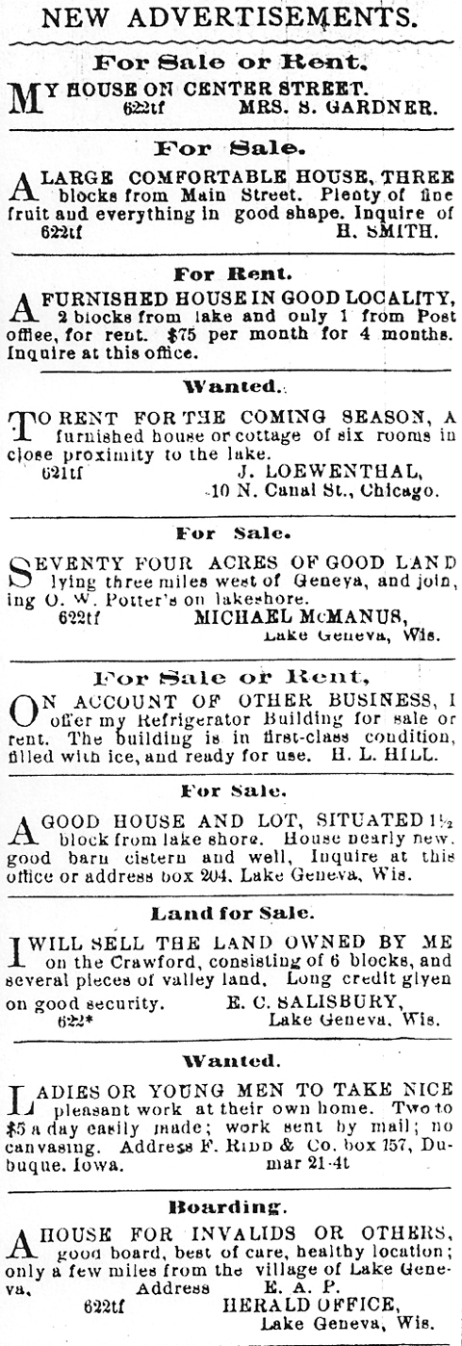
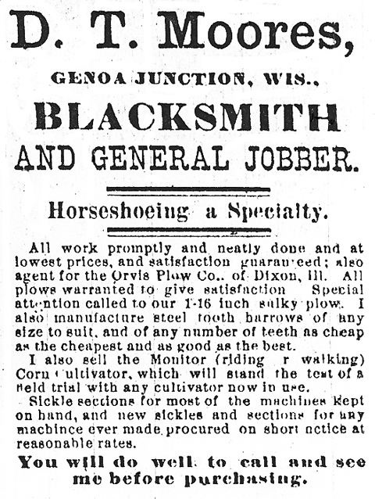
The Lake Geneva Old Times is sponsored and financially supported by the Lake Geneva Historic Preservation Commission. Each issue represents one year of authentic old news. It is free to the public. The public may obtain copies at the Geneva Museum, Grandma Vickie’s Café, Dunn Lumber, Piggly Wiggly, Caribou Coffee & Starbucks. Back issues can be purchased for 50 cents each.
Editor, Denny Teichow, 262-248-6313.


